
Creating Futures
(Choosing Regional Futures - FRST Project)
Spatial Decision Support System
Draft Specifications

Daniel Rutledge¹
Garry MacDonald^{2, 3}
Michael Cameron⁴
Graham McBride⁵
Jacques Poot⁶
Frank Scrimgeour⁴
Robbie Price¹
Derek Phyn⁶
Hedwig van Delden⁷

¹Landcare Research, Private Bag 3127, Hamilton
²New Zealand Centre for Ecological Economics, Palmerston North
³Market Economics, Takapuna
⁴University of Waikato, Hamilton, New Zealand
⁵National Institute for Water and Atmospheric Research, Hamilton
⁶Environment Waikato, PO Box 1040, Hamilton
⁷Research Institute for Knowledge Systems, Maastricht, The Netherlands

Landcare Research Contract Report: LC0708/063

PREPARED FOR:
Environment Waikato
PO Box 1040
Hamilton

DATE: November 2007
Reviewed by:  Dr Bob Frame  Scientist  Sustainability & Society  Landcare Research | Approved for release by:  Dr Richard Gordon  General Manager  Environment & Society  Landcare Research

© Landcare Research New Zealand Ltd 2007
No part of this work covered by copyright may be reproduced or copied in any form or by any means (graphic, electronic or mechanical, including photocopying, recording, taping, information retrieval systems, or otherwise) without the written permission of the publisher.

Disclaimer
The findings in this report are specific to this project. Landcare Research accepts no responsibility where information in the report is used for any other purpose, and will not be liable for any loss or damage suffered as a result of such other use.
Contents
Summary 5
Reader's Guide 9
1 Introduction: Choosing Regional Futures Project 10
1.1 Overview 10
1.2 Objective 2 – Spatial Decision Support System Development 11
SDSS Development Plan 11
SDSS Development to Date 13
2 Policy Context: The Need for a Spatial Decision Support System 14
2.1 Overview 14
2.1.1 Resource Management Act (1991) 14
2.1.2 Local Government Act (2002) 15
2.2 What is a spatial decision support system? 16
Definition 16
Components 17
3 Methodology for Developing SDSS Specifications 18
3.1 Brief Overview of the Waikato Region 18
3.2 Objectives for the Spatial Decision Support System 21
3.3 Policy and Planning within the Waikato Region 21
3.4 Key Considerations Guiding SDSS Scope and Design 24
Choosing Futures Waikato Regional Community Outcomes
and MARCO Indicators 25
Key Drivers from Qualitative Scenarios 26
Comparison of Community Outcomes from 4 Selected Regions 29
3.5 Spatial Decision Support System Scoping Workshop 32
4 Draft SDSS Specifications 36
4.1 Overall System Design 36
Overview 36
NZ to Global Scale 36
Regional Scale 36
District Scale 37
Local Scale 37
4.2 GEONAMICA® Framework - RIKS 39
5 Climate Change Scenarios- NIWA 42
5.1 Model Summary 42
5.2 Model description 42
5.3 Links to other models 42
6 Hydrology - NIWA 44
6.1 Model Summary 44
6.2 Model description 44
6.3 Links to other models 45
7 Waikato Region Dynamic Economy-Environment Model – NZCEE 46
7.1 Model Summary 46
7.2 Model Description 47
7.2.1 Population Module 48
7.2.2 Labour Force Module 48
7.2.3 Growth Module 49
7.2.4 Economic Module 50
7.2.5 Economic Physical Flow and Environment-Economy
Physical Flow Modules 51
7.3 Links to Other Models 52
8 Water Quality – NIWA 53
8.1 Model Summary 53
8.2 Model description 53
8.3 Links to other models 56
9 Zoning – District Councils via EW 57
9.1 Model Summary 57
9.2 Model Description 57
9.3 Links to other models 57
10 Demographics – University of Waikato, Population Studies Centre 59
10.1 Model Summary 59
10.2 Model Description 59
10.3 Links to Other Models 61
11 Dairying – University of Waikato, Department of Economics 62
11.1 Model Summary 62
11.2 Model Description 62
11.3 Links to Other Models 63
12 Biodiversity – Landcare Research 64
12.1 Model Summary 64
12.2 Model Description 64
12.3 Links to Other Models 65
13 Land Use – RIKS 67
13.1 Model Summary 67
13.2 Model Description 67
13.3 Links to Other Models 73
14 Preliminary Evaluation of the SDSS to Inform Policy & Planning 74
14.1 Key Community Outcomes and related Core MARCO Indicators 74
14.2 Key Drivers from the Qualitative Scenarios 75
14.3 Community Outcomes from Other Regions 75
Sustainable Environment 76
Quality of Life 77
Sustainable Economy 78
Culture and Identity 79
Participation and Equity 79
15 Next Steps 81
15.1 Overall SDSS Design 81
15.2 Specific Options for Recommended Model Components 82
Acknowledgements 83
References 84

Summary
Project and Client
Choosing Regional Futures is a 4-year project funded by the New Zealand Foundation for Research, Science and Technology. The project brings together an interdisciplinary team consisting of a key end-user (Environment Waikato) and social, environmental and economic researchers. The project aims to develop new methods and tools to support integrated, long-term planning by 1) developing processes to evaluate, deliberate, and choose futures through scenario analysis and multi-criteria evaluation frameworks, and 2) developing a spatial decision support system (SDSS) to support the evaluation and deliberation processes. Together these tools will help councils evaluate links and trade-offs between economic, environmental and social/cultural outcomes and the cumulative effects of many decisions over space and time.
This report outlines the first phase of development and provides the draft specifications for the SDSS being developed as part of Objective 2. An SDSS is an integrated framework designed to help examine weakly structured or unstructured problems characterised by many actors, many possibilities, and high uncertainty. An SDSS is being developed for the Waikato region (North Island) to support Environment Waikato’s Long-term Council Community Planning Process.
Objective
- Develop draft specifications for an SDSS to support evaluation and deliberation of strategies and scenarios related in the context of long-term council community planning as required by the New Zealand Local Government Act (2002)
Methods
- Three key sources of information were reviewed to identify important issues and themes that the SDSS should address and guide development of draft specifications:
  - Regional community outcomes and associated indicators from the Choosing Futures Waikato Community Outcome Process. Five high level themes and many outcomes were identified as part of the process. In addition, an initial set of 75 core indicators was identified to inform progress towards those potential outcomes
  - Qualitative scenarios developed in Objective 1 of the project
  - Community outcomes from 4 other regions (Auckland, Bay of Plenty, Horizons, and Cantebury) for comparative purposes.
- A workshop was held in January 2007 to develop a preliminary overall system design and
Results
- Draft SDSS specifications consist of an overall systems design that includes integrated components operating at four spatial scales:
  - NZ & the World
  - Waikato region
  - Districts
  - Local, i.e. 200 m x 200 m grid cells (Figure 4).
- The SDSS will be implemented in the GEONAMICA® framework. GEONAMICA® is an object-oriented application framework developed by the Research Institute for Knowledge Systems. It is especially tailored for developing an SDSS that features integrated dynamic models as core elements and has an extendible toolbox containing ready-to-use software building blocks required for the development of models, analysis tools and user interfaces.
- New Zealand to Global Scale
  - Climate Change Scenarios – consist of standard IPCC climate change scenarios down-scaled for use at scales relevant to New Zealand and the Waikato region
  - External Drivers – consist of key factors that may strongly influence New Zealand and/or the Waikato region, such as foreign exchange rates, world commodity prices, interest rates, credit availability, migration trends, technological developments, etc. The project team is currently evaluating the list of potential indicators to include in the SDSS.
- Regional Scale
  - Waikato Region Dynamic Economy-Environment Model (WRDEEM) – a system dynamics model of region-wide environment-economy interactions adapted from a model developed for Auckland (McDonald 2007). WRDEEM consists of six sub-modules: Population, Labour Force, Growth, Economics, Economic Physical Flow, and Environment-Economic Physical Flow. It models the flow of economic commodities as traded on markets in both monetary ($NZ₁₉₉₈) and physical terms (tonnes), along with the flow of associated natural resource inputs (e.g., land, energy, water) and residual outputs (e.g., wastes, pollutants and emissions). The model simulates the combined environmental and economic implications of economic change in the Waikato Region between 1998 (base year) and 2051. The model is driven by scenarios of economic growth
  - Hydrology – consists of the TOPNET model, which simulates surface and shallow groundwater hydrology to generate hourly time series of river flow and soil moisture (Bandaragoda et al. 2004). Model simulations can cover periods of several years to decades. TOPNET also includes impacts of spatially varying climate, soil, vegetation and topography on hydrological response
  - Water Quality – represents an adaptation of U.S Geological Survey SPARROW model to New Zealand (Elliott et al. 2005). SPARROW estimates pollution loads, (e.g., total nitrogen) at selected points in a river network as a function of upstream catchment characteristics including land use
- District Scale
  - Zoning – consists of zoning maps prepared as part of district/city plans. Zoning delineates where different land use activities are or are not permitted. It controls land use change in the local scale (see below) by controlling where different land uses can and cannot occur
  - Demographics – consists of the PROJECTIONS model that projects population over time, expressed as 1-year male and female age cohorts. The intent is to run a separate population model for each district that will estimate birth rates, death rates, and net migration rates from each district to other districts within the Waikato region, and from each district to outside the region
  - Dairying – will model the effects of dairying intensity aggregated by district based on a combination of physical attributes or suitability, production targets (i.e. kg/milk solids/ha desired), and management practices
- Local Scale
  - Land Use Change – dynamically models land-use change over time based on demand for land uses generated at the district or regional scales and a combination of four other factors: zoning, suitability, accessibility, and local influence (Engelen et al. 1997). Suitability estimates the biophysical suitability of land for different uses. Accessibility typically relates to travel distances, which can affect the desirability of some land uses such as housing Local influence measures the influence of neighbouring land uses on a land use at a particular point.
  - Biodiversity – will track changes in indigenous and exotic land cover over time. It combines information on land cover with information on protected areas and land environments to provide information on terrestrial biodiversity status across a range of scales. We are also investigating incorporating information on freshwater biodiversity
  - Spatial Indicators – track the status of different model inputs and outputs over time. Indicators would consist of a series of maps depicting indicator change over time. Land-use change is an example of a basic indicator that can be generated. The series of maps can be saved as an animated image and use for reporting, communication, and education purposes.
Conclusions
- We qualitatively evaluated the proposed SDSS system design’s ability to inform key community outcome and indicators and key drivers and its relevance to important themes and outcomes identified in the four comparison regions.
- Overall the draft SDSS would provide the most information about community outcome themes related to sustainable economy and sustainable environment. It would provide some information on quality of life and little to no information about themes related to culture and identify or participation and equity. The project team found the last two themes particularly difficult to interpret from a modelling perspective.
- Overall the SDSS appears to provide a good coverage of key drivers identified in the qualitative scenarios across the three scales:
  - World: Climate Change, Population, Market Changes, Globalisation
  - New Zealand: Demographic Trends, Lifestyles, Economy, Energy, Housing
  - Waikato Region: Land Use, Auckland Urbanisation Pressure, Economy, Governance.
  - Economic and demographic issues appear the most well represented through the WRDEEM and PROJECTIONS models. Other SDSS components addressed other issues, mostly at regional scales. Housing affordability and governance appeared the least well addressed. These issues will be examined more closely as specifications for the SDSS are finalised.
- Assessing the SDSS’s ability to address key drivers or issues from other regions was the most problematic and subjective given the range of issues identified across those regions and the different approaches to identifying and articulating community outcomes. The draft SDSS design addresses several common issues (Economy, Land Use, Demographics, Water Quality, Climate Change, Biodiversity). The Dairying component has less relevance to other regions, but otherwise the SDSS appears sufficiently basic and robust enough that it could be adapted to those other regions within New Zealand without the need for major design modifications. Various model relationships and parameters would definitely require re-estimation or recalibration if transferred to another region.
Next Steps
- Interacting with end-users, particularly staff at Environment Waikato, to review draft SDSS specifications and determine how well they fit with their current and emerging needs for policy development and resource management under the Local Government Act and Resource Management Ac
- An alignment workshop will be held in which researchers and end-users will come together to examine the draft SDSS specifications, identify gaps and suggest possible changes, and decide amongst various options that have been arisen during development.
- Identify and explicitly characterise linkages among model components
- Based on the tasks listed above, prepare final specifications for the SDSS.
Reader's Guide
This scoping report has been organised around three main themes:
- Context – Sections 1 to 3
- Draft SDSS Specifications – Sections 4 to 12
- Initial Policy and Planning Implications – Sections 13 & 14
A reader interested in understanding the entire process of SDSS development to date would benefit from reading the entire document.
A reader interested in the approach and methodology being used to develop the SDSS within the context of the Choosing Regional Futures project would benefit most from reading Sections 1 to 3. Those sections provide an overview of the project and outline the thinking and process used in the project to scope the draft SDSS specifications.
A reader interested in a quick introduction to the SDSS would benefit most from reading Section 4 – SDSS Overview. Further detail on any of the model components follows in Sections 5 to 12.
A reader interested in an initial assessment of how the SDSS could inform policy and planning should read Sections 13 and 14. This represents a first attempt to identify direct links from the SDSS to applications in policy, planning, and management.
Regardless of how much or how little of the document is read, the reader should be aware that this scoping report represents the first step of an iterative process of SDSS definition and development. Many questions and much detail remain to be resolved. The project has and will continue to follow an iterative process that involves interactions among researchers and end-users to scope and define specifications for an SDSS that provides insights into knowledge and methods for developing such tools from a research perspective and produces an SDSS that is both relevant and useful to end-users.

Introduction: Choosing Regional Futures Project

Overview
Choosing Regional Futures is a 4-year FRST-funded research project, begun in July 2006, aimed at developing, testing and implementing integrated tools designed to inform communities of the long-term effects of current development patterns and trends and to enhance choosing and planning for desired futures.
The project brings together an interdisciplinary team of stakeholders (Environment Waikato, the lead agency) and social, environmental and economic researchers within New Zealand (Landcare Research, AgResearch, New Zealand Centre for Ecological Economics, NIWA, Scion, University of Waikato) and internationally (Research Institute for Knowledge Systems – Netherlands and Université de Versailles Saint Quentin-en-Yvelines – France).
The Choosing Regional futures project has two objectives:
- Objective 1: develop processes to enable evaluation, deliberation and choice of alternative futures for social, environmental, economic and cultural changes through the use of scenario analysis linked to multi-criteria evaluation frameworks
- Objective 2: develop a spatial decision support system (SDSS) that integrates key aspects of the economy, environment, and society/culture. The SDSS will allow users to explore plausible futures of regional development in a quantitative and spatially explicit manner, evaluate and compare different policy and planning strategy options, and help monitor and report on progress towards achieving long-term sustainable community goals and outcomes.
The tools developed through the project will expose links and trade-offs between economic, environmental and social/cultural outcomes, including cumulative effects over space and time. The aim is that the information, knowledge and tools from the project can be widely used and applied for policy development, planning, and resource management, initially by regional and local/city councils and eventually by other organisations.
The research project has been designed to insure close interaction between researchers and end-users such that the resulting SDSS can be integrated into strategic planning and policy making and resource management by regional and local councils. The question of exactly how the SDSS will be used by councils is an active component of the research. By linking researchers and end-users from the beginning, the project serves as a direct pathway for uptake of the information, tools and knowledge gained by councils and allows them gradually to build their capacity and capability using tools like the SDSS to inform integrated, long-term planning for the future.
This report provides the draft specifications of the SDSS being developed within Objective 2. The draft specifications represent the first step of system definition, which itself is the first in a series of four phases in the definition, design, and development of the SDSS for the Choosing Regional Futures project (Figure 1).
System Definition
Collection of Data & Components
Integration & Calibration

Optimisation
Fig 1. Four stages of SDSS development in Objective 2 of the Choosing Regional Futures Project.

This report provides the context and need for the SDSS, overviews the process to date used to develop the first draft specifications, presents the draft SDSS specifications including the individual model components, and broadly outlines the type of outcomes that could be expected in terms of application and development.

Objective 2 – Spatial Decision Support System Development

SDSS Development Plan
Objective 2 seeks to develop an integrated (economic, environmental, social/cultural) SDSS that allows users to explore “what-if” questions related to complex issues of sustainable development that require integrated planning and decision-making, e.g., for regional development and the community outcomes process (Oxley et al. 2002; Englen et al. 2003).
Advantages of such an approach include
- integration of cultural, economic, environmental, and societal issues
- identification of links and feedbacks among issues
- limitations are explicitly identified, i.e. only so much land, soil, and water is available,
- demonstration of the importance of location in determining environmental effects
- aggregation or disaggregation of information/data/indicators across scales from national to local.
Potential limitations for developing an SDSS include
- lack of any spatially explicit data or data at the appropriate resolution
- poor knowledge of single processes or links among processes
- the technical complexity involved in developing such systems.
SDSS development (Figure 1) consists of a 4-step process: 1) system definition, 2) collection and development of data and components, 3) integration and calibration, and 4) optimisation (Figure 1).
Phase one, system definition, consists of identifying 1) the issues/questions/outcomes that the SDSS should address and 2) identifying model components, data, and links among them that would help address those issues and questions. The research team will list key research questions, review regional community outcomes, and compile lists of available and desired knowledge, data, and models. Based on that information, the team will scope a draft SDSS specification that balances prioritisation and feasibility of addressing key questions/issues/outcomes.
The specific nature of the SDSS will develop during the project but will address at least three essential issues:
- dynamic land use change (RIKS, Landcare Research)
- economic development and economic-environment relationships (NZCEE, UoW)
- demographic trends (UoW).
The SDSS will also address other key issues/questions such as water quality (e.g., NIWA’s Sparrow), energy (e.g., NZCEE’s ECOLINK), or transportation (e.g., RIKS transport model). The team will work with council staff to identify and incorporate aspects of council planning (valuation/rates, infrastructure, asset management) into the SDSS. The research team will collaborate with end-users in an iterative process to define, refine and prioritise the list of key questions/needs to produce a final SDSS specification.
Phase two, collection and development of data and components, will consist of 1) gathering existing data and models and adapting them for inclusion in the SDSS, 2) generating new data or models that may be required to address key questions, and 3) identifying required links among data/components when integrated within the SDSS. As discussed above, we cannot anticipate all needs because requirements will evolve during the project. We can, however, discuss needs for the three essential components outlined above.
- Land use: Land-use modelling requires a) spatial land use, b) zoning, c) land suitability, and d) land accessibility. LCR has begun development of land-use layers by combining information on land cover, topographic mapping features, and council zoning. LCR will continue that development and also prepare zoning data (councils), land suitability (Land Resource Inventory, National Soils Database, in-house experts), and land availability (distance to transport i.e. roads).
- Economics: Both NZCEE and Waikato University have produced regional input-output models for the Waikato region. These models and related analyses require further specification so that accurate economic indicators can be generated at the sub-region level. Further, the economic models need to be structured so they adequately integrate with biophysical data to generate information which is of relevance for decision makers. This work will be informed by our existing linkages with Statistics NZ who are committed to enhancing both their regional statistics and their environmental statistics. To this end UoW staff has already had two meetings with Statistics NZ staff.
- Demographics: There have been recent developments in sub-national demographic projection methodologies, including probabilistic methods and macro or micro simulation approaches (Wilson & Rees 2005) and inward/outward migration models (Cushing & Poot 2005). The project will use these developments to develop spatially explicit approaches to regional or, where data permit, sub-regional long-term projections.
Phase three, integration and calibration, will involve integrating all data and components into the SDSS and calibration/testing of SDSS outputs and adjustment of model equations and parameters accordingly. The SDSS will be implemented in the GEONAMICA® software development framework developed by RIKS. GEONAMICA® is an in-house software built on the Microsoft Com/ActiveX software model that allows them rapidly and efficiently to develop an SDSS that uses existing components, incorporates others components, or develops new components from scratch. They also have existing methodologies for testing/calibrating model outputs. Existing spatial data will be converted to a common format for use in the SDSS. The effort required to incorporate existing models or develop new models varies according to scientific and technical sophistication. For example, conceptual models with no existing software base take much longer to incorporate than established models with a mature software base. On completion of integration and calibration, the research team will present the first iteration of the SDSS to end-users as part of the Deliberation Matrix process (Objective 1.1, Milestone 1.1.6).
Phase four, optimisation, will involve fine-tuning the overall SDSS to enhance usability and performance. Key aspects will include improving the user interface for operability and understanding, optimising the software code for maximum execution speed, enhancing the scope and design of outputs such as maps and scenario reports, documenting the metadata, and any issues relating to up-dating and maintenance of key datasets. Future opportunities for enhancing the SDSS will also be identified, including 1) additional components/models to address specific areas or issues, 2) collection of missing data for application, calibration and validation, and 3) development of an implementation plan for getting the system used in practice, especially by people or groups not included in the current project.

SDSS Development to Date
To date the overall process used to develop draft SDSS specifications has followed the initial conception of how SDSS development would progress. However, the linear process outlined in Figure 1 greatly simplifies the iterative process that is actually taking place. The draft specifications as outlined in this report resulted from a series of interactions among researchers, among end-users, and among researchers and end-users. During this first stage of development, it became clear that additional iterations will be needed to define and refine the SDSS, as both the research team and the end-users learn more about each other and potential SDSS capabilities and limitations. The interactions will insure that the end-users, in this case primarily EW, can uptake and meaningfully apply the SDSS in policy development and resource management planning.

Policy Context: The Need for a Spatial Decision Support System

Overview
Ensuring the well-being of current and future generations of New Zealanders requires taking a sustainable development approach. This includes recognising the links and interactions between environmental, social, cultural and economic activities and outcomes when making decisions, understanding the trade-offs among those outcomes, identifying the drivers of change at various scales and anticipating the potential effects of actions. Such effects may range from the consequences of single large events (e.g., volcanic eruptions) to the cumulative effects of many small decisions, or what the Parliamentary Commissioner for the Environment calls “death by a thousand cuts” (Parliamentary Commissioner for the Environment 2002).
Consequently, New Zealand, like many countries, has adopted policies to promote sustainable development (Department of Prime Minister and Cabinet 2003), which is usually defined as:
…development which meets the needs of the present without compromising the ability of future generations to meet their own needs (Bruntland Commission 1987).

While these policies and programmes provide broad strategies for helping move towards more sustainable development, the main task of delivering sustainable development falls under the aegis of two key pieces of New Zealand legislation: the Resource Management Act (RMA) and the Local Government Act of 2002 (LGA). As a set, the RMA and LGA establish the basic governance structures for deciding how to manage the allocation and use of New Zealand's natural resources and operationalising the broader principles of sustainable development. The LGA creates the territorial authority system of regions and districts (and unitary authorities) and gives them the power to carry out services within their jurisdiction. Similarly, the RMA provides an overall framework within which territorial authorities plan for and manage the natural resources within their jurisdictions (Harris 2004). Because they operate at the interface of policy, knowledge, management, education, and communication, territorial authorities within New Zealand have the opportunity to take a lead role as enablers of sustainable development within New Zealand.

Resource Management Act (1991)
The RMA became law in 1991 and is the keystone piece of New Zealand legislation that governs processes for the allocation and use of natural resources. Section 5 of the RMA outlines its purpose:
Purpose – (1) The purpose of this Act is to promote the sustainable management of natural and physical resources.
(2) In this Act, “sustainable management” means managing the use, development, and protection of natural and physical resources in a way, or at a rate, which enables people and communities to provide for their social, economic, and cultural well-being and for their health and safety while –
(a) sustaining the potential of natural and physical resources (excluding minerals) to meet the reasonably foreseeable needs of future generations; and
(b) safeguarding the life-supporting capacity of air, water, soil, and ecosystems; and
(c) avoiding, remedying, or mitigating any adverse effects of activities on the environment.

The RMA is effects-based in that it evaluates and controls activities based on their overall effect. In that sense, it does not prescribe absolute limits on the use of resources but instead requires deliberation as to whether intended activities cause significant effects. Effects can be positive or adverse; temporary or permanent; in the past, present, or future; singular or cumulative; high probability; or low probability but with high potential impacts (RMA, Section 3).
The RMA establishes several mechanisms for the governance of natural resource use at a number of levels. These mechanisms range from development of national policy statements intended to provide consistent guidelines on resource use, through regional policy statements, to regional and district plans, and finally to consents issued for specific projects or activities (Harris 2004). However, to date only one national policy statement, the New Zealand Coastal Policy Statement, has been prepared, and that statement was explicitly required in the RMA. Other national policy statements have clearly been optional.
In terms of the Choosing Regional Futures SDSS, the policies and plans of regional and district/city councils will affect different aspects of culture, economy, environment and society at different scales and to different degrees. For example, regional policy statements and/or plans include rules that affect the ability to undertake certain activities in certain places, thus limiting the potential suitability of land for different uses. District plans include zoning rules that directly regulate the types of land uses permitted in different places, e.g., residential, commercial, agricultural, etc.

Local Government Act (2002)
The LGA is the key piece of legislation that creates territorial local authorities and imbues them with the power to govern activities within their jurisdictions. Recent (2002) changes to the LGA represent a significant step towards sustainable development, whereby

… this Act … provides for local authorities to play a broad role in promoting the social, economic, environmental, and cultural well-being of their communities, taking a sustainable development approach (Local Government Act, Section 3).

As part of their new responsibilities, councils must now prepare a long-term council community plan (LTCCP). The plan must 1) identify, prioritise and integrate economic, social, cultural and environmental outcomes that the community wants to achieve in the long term, 2) describe councils actions to achieve those outcomes, 3) be for at least 10 consecutive years, and 4) provide “integrated decision-making and co-ordination” of council resources (LGA, Section 93). Councils must report on progress towards achieving community outcomes every 3 years and must inform the community about important issues so that stakeholders and the public can effectively participate in community planning processes and councils can make informed decisions. In essence, long-term council community plans aim to achieve a holistic, integrated level of planning required for sustainable development.
The requirements of the Act present new, complex, and challenging requirements for all 86 local councils. It demands more information, including the development of integrated datasets, new integrated models, and decision support systems to evaluate general or specific (i.e. sectoral) issues. It also requires an understanding of knowledge and capabilities (e.g., systems analysis) that many councils currently lack, and the ability to use the new knowledge, tools, and methods effectively in community consultation processes. The breadth and complexity of the task at hand extends beyond the ability of any single organisation to develop and/or implement.
All local councils have produced a first-generation LTCCP that outlined both desired community outcomes and council plans for contributing to those outcomes. The next requirement within the LTCCP process includes the first 3-yearly update in 2009.

What is a spatial decision support system?

Definition
A spatial decision support system or SDSS is an integrated framework designed to help examine weakly structured or unstructured problems (Figure 2). Because they are characterised by high levels of uncertainty, potential conflicts, or both, such problems differ from structured problems, which are tractable and understandable, often with a single, optimal solution. Conversely, many of the complex problems society faces today fall into the weakly structured or unstructured categories because they lack a single, objective solution. Ludwig (2001) calls them “wicked” problems with no definitive formulation, no stopping rule, and no tests for a solution. Functowicz and Ravetz (1991) call them “post-normal” problems that involve many actors with legitimate perspectives and high uncertainty.

weakly structured
problem
structured
problem
weakly structured
problem
unstructured
problem
Uncertainty

Conflicts
Fig. 2 Conceptual categorisation of problems (van Delden 2000).

In terms of resource management within New Zealand, and within the Waikato region in particular, an example of a structured problem might be: what is the maximum allowable temperature of water discharged into the Waikato River to maintain overall water temperature at or below thresholds needed for the survival of key aquatic species? A weakly structured problem might be: how much water can we annually extract from the Waikato River to meet human needs while maintaining minimum flows for electricity generation? Finally, an unstructured problem might be: how do we best allocate water from the Waikato River to meet the cultural, economic, environmental, and societal needs of the Waikato region and indeed needs of other regions that might also benefit from using the services the river provides (i.e. Auckland region water supply)?
An SDSS helps users explore feasible alternative futures by combining knowledge, data, and models in a flexible and easy-to-use manner. A good SDSS will support different decision-making styles and adapt over time to the needs of the particular user through interactive and iterative processes. An SDSS has a significant advantage over a non-spatial DSS because it has the ability to store and manipulate complex spatial data structures, conduct analyses within the domain of spatial analysis, and provide spatially explicit output in terms of maps and other reporting tools. This provides a robust framework for exploring resource management issues by highlighting potential limits to resources use (e.g., only so much land, water, energy, etc.) and the consequences of different allocation schemes. The use of models in a SDSS, in particular in the environmental domain, inevitably involves considerable uncertainty. In particular, the input to a model is subject to many sources of uncertainty including input data layers that are imprecise or inaccurate, absence of information, subjective criteria, and poor or partial understanding of the driving forces and mechanisms (model conceptual uncertainty). While there is ongoing research into managing and analysing the impact of uncertainty (Antunes and Dias 2007), for example through Monte Carlo simulation (de Kort and Booji 2007), a more informal ad-hoc approach of running the SDSS using a few alternative data layers, scenarios, criteria, model parameter sets or submodels and comparing results, is sometimes employed.

Components
Conceptually, an SDSS has five components: 1) a database management system; 2) a model base-management system; 3) a display generator; 4) a report generator; and 5) a user interface for facilitating the use of the entire system (Figure 3). Data within the SDSS can be either aspatial or spatial. Models can range in complexity from simple functions or relationships to complex process models.

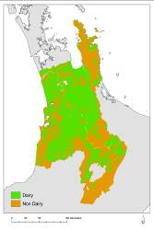
Database
Management
System
(DBMS)
Model Base
Management
System
(MBMS)
Display
Generator
Report
Generator
User Interface
Fig. 3 Conceptual diagram of SDSS components.

Methodology for Developing SDSS Specifications

Brief Overview of the Waikato Region
The Waikato region is located in the north central North Island of New Zealand. The region covers an area of approximately 25 000 km² and includes all or portions of 12 district/city councils (Figure 4). It encompasses a diverse range of environments and ecosystems, from the central volcanic peaks and mountains of Ruapehu, Tongariro, and Ngrahoi, through rolling high country, to lowland coastal plains and coast. The major feature of the region is the Waikato River, which flows out of Lake Taupo north through the centre of the region, and eventually turns west south of Auckland where it joins the Tasman Sea.
Much of the Waikato region has been converted to primary production. Lowlands and rolling high country supports agriculture (55%), particularly dairy and sheep/beef production. Exotic forestry generally occurs on steeper slopes and/or poorer soils of the high central volcanic plateau (Figure 4). Forestry recently occupied as much as 15% of the region, but recent large-scale conversions to dairy are reducing its overall extent. Natural vegetation and cover remains on ~28% of the region, principally on steep slopes or high elevation areas. Urban and other miscellaneous land covers account for less than 2% of the region’s total land area.
The Waikato region had an estimated population of 387 700 as of June 2006 (Statistics New Zealand, Medium Estimate, date?), making it the 4th most populous region in the country. Hamilton, with 158 500 residents, is the fourth largest city in New Zealand. Also as of June 2006, the region had an estimated 145 000 households. The estimated Gross Regional Product for the Waikato Region was ~$12 billion NZD or 9.5% of New Zealand GDP.

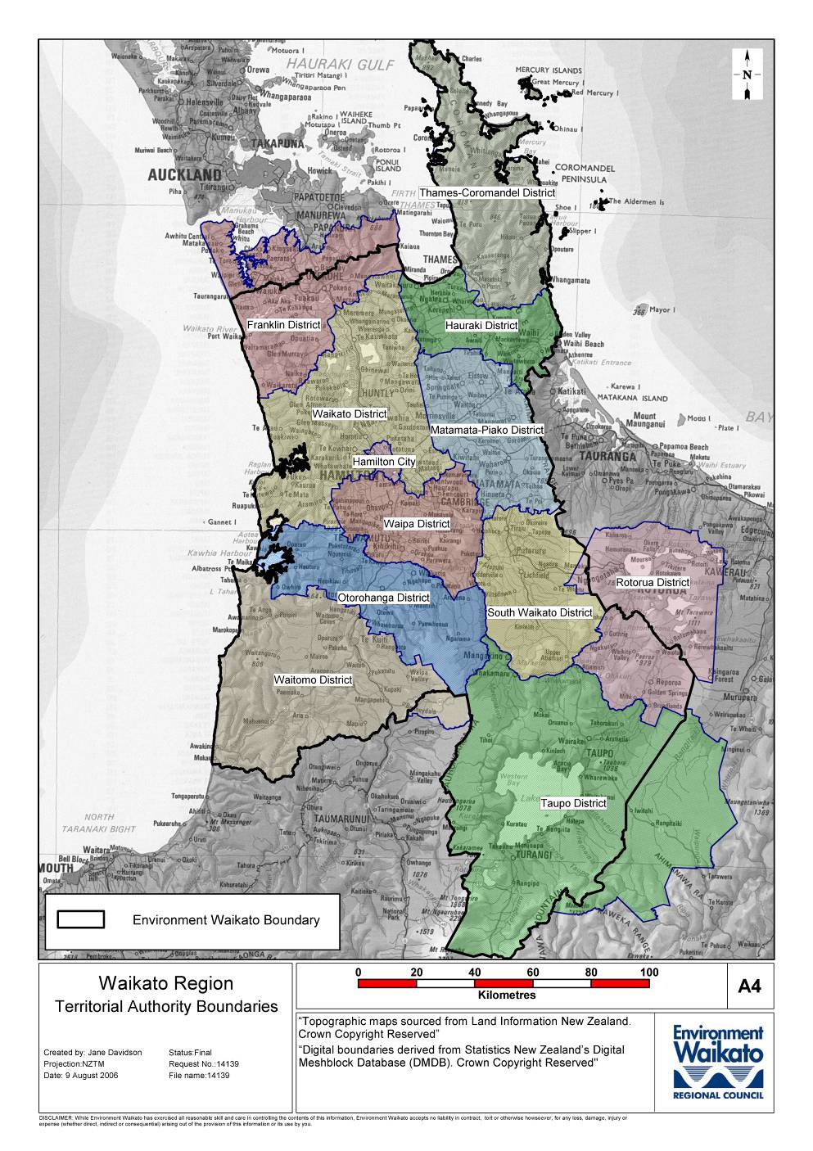
Fig. 4 Map of the Waikato Region and included District Councils.

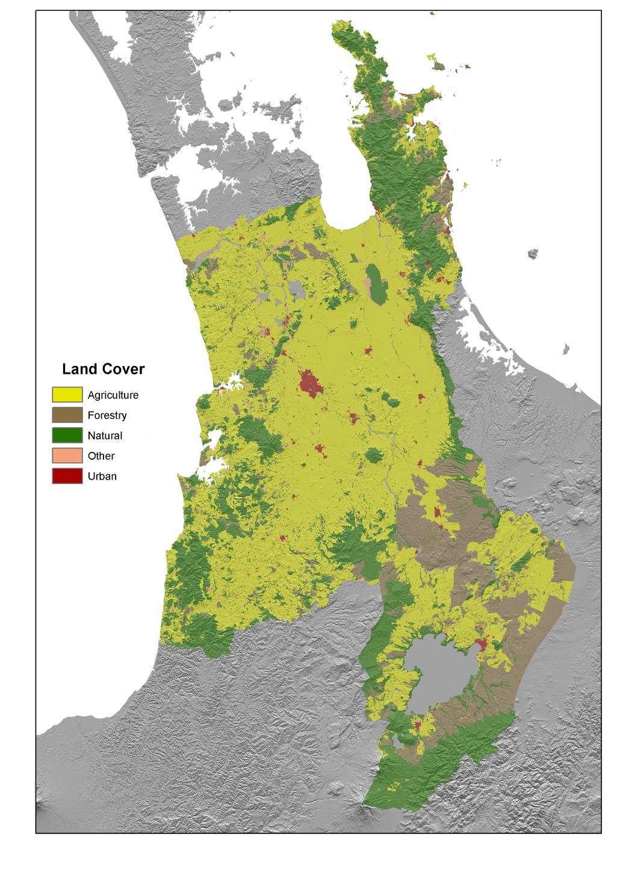

Fig. 5 Major land cover/use within the Waikato Region as of 2001/2002, based on New Zealand Land Cover Database Version 2.

Objectives for the Spatial Decision Support System
If it is to be properly understood and used, the Choosing Regional Futures SDSS, like any good model or tool, should have a well-defined purpose. This requires defining what issues or questions the SDSS should help address, knowing what components to include and exclude, understanding its strengths and weaknesses, and having the organisational capacity to employ it correctly and effectively. This stage represents the first attempt to define issues/questions and decide what to include and, perhaps more importantly, what not to include in the SDSS. It also provides a preliminary assessment of SDSS strengths and weaknesses. The final SDSS specifications (what to include and not include), full assessment of strengths and weaknesses, and issues of organisational capacity remain to be addressed through on-going interaction and consultation with the project’s end-user partners.
The Choosing Regional Futures project intended from the outset to design, develop, and deploy an SDSS that helps councils carry out long-term planning as required under the LGA’s new LTCCP requirements. As discussed above, both the RMA and LGA require councils to manage the resources within their jurisdictions in a sustainable manner. The LGA in particular now requires councils to adopt a longer-term, in this case at least 10-year, perspective. Councils have begun this process by engaging their constituents to develop shared (i.e. council and constituents) community outcomes for the region or district and now have LTCCPs that outline what councils will do to help achieve those outcomes. Helping deliver the desired outcomes through integrated, long-term planning will not be easy as highlighted in Environment Waikato’s LTCCP:

The task given to regional councils – balancing the requirements of today with the needs of tomorrow – is a difficult one. We constantly try to look ahead and anticipate what pressures we will face, a challenge that is made more difficult by the size and complexity of the Waikato region. (Environment Waikato, Long-term Council Community Plan, YEAR, p. 24).

The shift to more integrated, long-term management of the region’s resources will require new approaches, new knowledge (or new means for combining and applying existing knowlege), methods and tools. For example, currently Environment Waikato's Regional Policy Statement contains a note stating “Environment Waikato is unable to prepare regional rules for the integrated management of natural and physical resources and the effects of the use, development, or protection of land of regional significance (RMA, s68)” (Environment Waikato Regional Policy Statement, YEAR?, p. 5). With the aid of the SDSS, councils can hopefully begin to develop, evaluate and compare different policy and planning strategies in an integrated fashion and better understand how well those strategies may or may not help contribute to the achievement of desired long-term community outcomes.
While the ideas and frameworks developed in the Choosing Regional Futures project would apply more broadly, the project specifically targeted councils and the LTCCP process given the critical role that both play with regard to resource management and community education and involvement. Together councils and the LTCCP process offer an exciting opportunity to help New Zealand as a whole move towards more sustainable development.

Policy and Planning within the Waikato Region
The Waikato region is governed by Environment Waikato, the regional council, and 12 district councils. Of the 12 district councils, eight occur entirely within the region, while the remaining four districts (Franklin, Rotorua, Otorohanga, and Taupo) straddle two regions (Fig. 4). Each council has developed an LTCCP under the LGA and a regional or district plan under the RMA. Councils also have Annual Plans that provide yearly updates or variation/changes to their LTCCP and the LGA requires that Councils review their LTCCP every three years.
One council, Taupo District, has even produced a very long-term growth management strategy (Taupo District 2050). The strategy’s vision talks of the district maturing into a place with a vibrant community spirit, vibrant economy, diverse range of opportunities, and an integrated approach to leading, managing, and funding growth (assumed to be economic) while managing the district’s resources in a sustainable manner. The strategy outlines 12 strategic directions to strongly guide future growth including district character, outstanding landscapes and natural areas, settlement patterns and urban form, tangata whenua, transport modes and connections, etc. Such objectives are indicative of the desire to continue to develop economically and socially but not at the expense of long-term environmental sustainability. Such objectives are necessary but present significant challenges because they involve many aspects of evaluation subject to different social and cultural perspectives.
Environment Waikato has surveyed residents to ask their opinions of the region and what environmental issues are important to them. The most recent survey in 2003 identified seven issues given the highest importance (Table 1). The survey demonstrated that many people thought conditions of many resources were getting worse. It also highlighted the dynamic nature of people’s opinions because it asked whether an issue was likely to be more, less, or as important in 5 years time.

Table 1 Important environmental issues identified during Environment Waikato’s 2003 community survey
Water quality | Compared with the 1998 and 2000 survey results, water issues continue to increase in importance. Water is also expected to be the most important issue in five years’ time. The community perceives water quality in local streams, rivers and lakes as becoming worse in the past few years.
Animal and plant pests | Seen as important in 2003, but by 2008 it is likely to drop to seventh on the list.
Waste disposal | What happens to our waste is likely to rate, in 2008, as the third most important issue. The availability of waste recycling services and facilities was considered to be getting better, and people mentioned their own recycling and composting efforts, but did not often mention reducing or reusing resources.
General pollution | The level of pollution – particularly that produced by businesses, farms and industries – was thought to be getting worse compared with previous years.
Transport | Transport has increased in importance for 2003, and in 5 years it is expected to be the second most important issue. People think traffic congestion on local streets, roads and highways has become much worse.
Air pollution | Although it has dropped its rating in importance from previous years, it is likely to rank fourth equal for 2008.
Population increases & town planning | These are emerging issues and their higher level of importance continues for 2008. Topics include urban sprawl and subdivision.

In addition to an LTCCP and regional/district and annual plans, each council has also developed various policies, strategies, bylaws and plans to address issues of importance to each particular council (Table 2). An inspection of the policies and plans reveals a number of broad trends. As called for under the RMA, Environment Waikato has primary responsibility for environmental resources within the region and also takes a key role in the development of regional transport issues. District councils have key responsibilities for infrastructure and assets including buildings, services such as wastewater, and other public facilities. Districts also have policies, either as part of their district plans or separately, aimed at managing or preserving amenities that give a place its unique character or identify such as landscapes, natural areas, open space, etc. Several councils have developed parallel policies for development contributions, dangerous and unsanitary buildings, transport and road safety, and dog control, while each Council has one or possibly several issues or resources unique to their area as would be expected.
Table 2 Additional regional and district council policies, strategies, and plans
Council | Policy & Strategy Documents | Planning Documents
Environment Waikato | Regional Policy Statement  Dangerous Dams Policy  Regional Pest Management Strategy  Regional Land Transport Strategy | Regional Coastal Plan  Protecting Lake Taupo  Regional Passenger Transport Plan  Regional Road Safety Plan  Shore Futures  Navigation Safety Bylaw 2006
Franklin | Dangerous and Insanitary Buildings Policy  Development Contributions Policy  Dog Policy  Earthquake and Prone Buildings Policy  Gambling Policy  Road Safety Strategy | Civil Defence Plan  Recreation Plan  Rural Fire Plan  Town Plans  Urban Design Action Plan  Waste Management Plan
Hamilton City | Community Development Strategy  Economic Development Strategy  Integrated Transport Strategy  myCouncil 2005 | Long Term Plan  Proposed District Plan  CityScope  Access Hamilton  Reserves Act Management Plan
Hauraki | Consultation Policy  Dog Control Policy  Earthquake-Prone, Dangerous and Insanitary Buildings Policy  Economic Development Strategy  Equal Employment Opportunity Policy  Gambling Act Venue Policy  Local Governance Strategy  Long-term Financial Strategy  Treasury Management Policy  Youth Policy | Civil Defence Emergency Plan  District Reserves Management Plan  Fire Plan  Waste Management Plan
Matamata-Piako | Consultation Policy  Dog Control Bylaw and Policy on Dogs  Liquor Licensing Policy  Earthquake-Prone, Dangerous and Insanitary Buildings Policy
Otorohanga | Governance Statement
Rotorua | Bright Economy Strategy  Central Business District Retail Strategy  Code of Conduct and Governance Statement  Development Contributions Policy  District Recreation Strategy  Employment Skills Strategy  Events Strategy  Governance Statement  Open Space Strategy Papa Atea  Rotorua Lakes Recreation Strategy  Strategy of the Lakes of the Rotorua District  Transport Strategy 2006  Visitor Industry Draft Strategic Plan | Broadlands Road Corridor Management Plan  Parks Asset Management Plan
South Waikato | Economic Development Strategy  Waste Management Strategy | Asset Management Plans  Tirau Concept Plan
Taupo | Cycling and Walking Strategy  Development Contributions Policy  Dog Policy and Bylaws  Earthquake Prone, Dangerous and Insanitary Building Policy  Horse Riding Strategy  Gaming Policy  Policy for the Older Person  Recreation Strategy  Taupo District 2050 Growth  Management Strategy  Tree and Vegetation Strategy | Asset Management Plans  Motoutere Recreation Reserve Management Plan  Nukukau Boat Ramp Area Reserve Management Plan  Owen Delaney Park Management Plan  Structure Plans  Tongariro Domain Management Plan
Thames-Coromandel | Biosolids Management Strategy  Development Contributions Policy  Occupational Safety and Health Policy  Tree Strategy 2003 | Asset Management Plans  Whangamata Tree Masterplan  Whangamata Wards Reserve Master Plan
Waikato | Conservation Strategy  Maori Liaison Policy and Guidelines
Waipa | Development Contributions Policy
Waitomo | Governance Statement  Policy on Appointment of Directors  Policy on Delegation of Authorities  Policy on Gambling  Policy on Investments  Policy on Liability Management  Policy on Making Policies  Policy on Partnerships with the Private Sector  Policy on Prostitution  Policy on Remission of Rate  Policy on Revenue and Financing  Policy on Significance

The full set of policies, strategies, and plans, when taken together, create a complex planning and regulatory environment within the Waikato region. They also comprise literally thousands of pages of documents covering a diverse range of issues and topics, some of which apply to the entire region, others only to parts of the region. Furthermore, these documents primarily account only for regional and local government perspectives. Factors outside the Waikato region clearly affect what happens within the region. These factors would include the rapid growth and development of the neighbouring Auckland and Bay of Plenty regions, national issues related to economic development, sustainable development, energy security, etc., and international issues such as market trends, exchange rates, migration trends, etc.

Key Considerations Guiding SDSS Scope and Design
Faced with such a complex set of issues, drivers, policies, and socio-political and environmental considerations, a key question regarding SDSS scope and development becomes simply: where to begin? In the Choosing Regional Futures project, no single theme or issue such as water resources or energy dominates. Rather, the project is attempting to give more-or-less equal emphasis to a range of key issues. This is both a benefit and a drawback. The benefit lies in the flexibility for defining the range of issues or questions that the SDSS could address. The drawback lies in the range of choice around what issues could be addressed. At the end of the day, choices have to be made on what is included or not included in the final SDSS specifications.
For the Choosing Regional Futures project, the starting point for designing the overall SDSS specifications began with three key sources of information:
- community outcomes identified by the Choosing Futures Waikato process and associated indicators developed by the Measuring and Reporting Community Outcomes (MARCO) project
- key drivers and issues identified by the qualitative scenarios developed in Objective 1 of the project
- community outcomes from 4 other regions in New Zealand (Auckland, Bay of Plenty, Horizons, and Canterbury) for comparative purposes.
The process can be likened to the process of triangulation used in determining geographic location. In the project’s case, the three sources of information provide independent (or semi-independent) reference points that can help guide SDSS development and help “show the way”. The Choosing Regional Futures community outcomes and related MARCO indicators and the key drivers and issues from the qualitative scenarios provide information from within the Waikato region itself. Comparison with community outcomes from other regions provides an assessment of the generality or uniqueness of different outcomes and issues. This is important because the aim is to develop an SDSS that has broad applicability within New Zealand even though the Waikato region provides the initial case study.
The three sources of information define a possibility space – to borrow a phrase from statistics – to explore and then, via an iterative process in consultation with key end users such as EW, prioritize and narrow down to a manageable subset based on an evaluation of importance, relevance, availability of knowledge/data/models.

Choosing Futures Waikato Regional Community Outcomes and MARCO Indicators
Environment Waikato and the 12 district councils in the region are partners in the development of the Choosing Futures Waikato process. The process has identified a shared, region-wide set of community outcomes that broadly outlines the desired goals for the future well-being of the region as a whole. The outcomes are organised into five broad themes:
- sustainable environment
- quality of life
- sustainable economy
- participation and equity
- culture and identity.
Each theme has an associated statement providing more detail about the intent behind that theme and a number of more specific outcomes (Table 3). The themes and outcomes are intended to help guide organisations throughout the region to deliver services that contribute towards achieving the desired goals and priorities for the future. Within Sustainable Economy, for example, the first statement indicates a desire for well-planned economic growth balanced with other needs and values. The Choosing Futures Waikato process is community-driven in that groups and individuals define the goals, rather than have them prescribed from a particular organisation or council.
The Choosing Futures Waikato community outcomes provided the starting point for SDSS design and development in that they broadly outline key areas or issues the SDSS should address, either at the theme level (e.g., sustainable economy ) or in the more detailed statements (e.g., heritage sites and landscapes of significance to whanau, hapu, and iwi are preserved and valued). While affirming the overall need for integrated assessment of key aspects of culture, economy, environment, and society, the community outcomes do not offer strong insights into what particular aspects of culture, economy, environment, or society require the most attention or have the highest priority.
Looked at in another way, the set of shared regional community outcomes as currently conceived represents a very large unstructured problem containing elements of high uncertainty (ability to deliver outcomes) and conflict (many actors with different views and priorities for the outcomes listed). While being an ideal candidate for SDSS, the lack of specific definition poses a problem by presenting many options for SDSS design.
The councils within the Waikato region have been running a parallel project, “Measuring and Reporting Community Outcomes” or MARCO. The MARCO team compiled, evaluated, and prioritised a list of potential indicators related each of the community outcomes (Choosing Futures Waikato 2006). The indicators provide more specific and in some cases quite exact measures that are more amenable to modelling within the SDSS. Therefore the process shifted to choosing models or components that could inform one or more of those indicators. As a result, SDSS outputs can map directly to indicators and ultimately community outcomes. The MARCO project essentially represented the first attempt to narrow down the “possibility space” of options by identifying explicit aspects of the community outcomes and possible ways in which to measure them. While the results of the MARCO project did not provide full resolution in terms of SDSS specifications, they provided an excellent starting point for evaluation and discussion.

Key Drivers from Qualitative Scenarios
Under Objective 1 of the Choosing Regional Futures project, a set of qualitative scenarios are currently under development for the Waikato region. These scenarios will provide narrative stories that outline possible or plausible future stories about how the future may unfold in the region over the next 30 to 50 years. Scenarios are not predictions about the future but an exercise to challenge our thinking about “what if” the future develops in ways that we do – or perhaps more importantly – do not expect.
In October 2006 a workshop was held that began the process of structured dialogue to create the future scenarios for the Waikato region and to gather information to inform overall SDSS development. Over 30 individuals from key stakeholders groups representing a range of perspectives and interests (government, business, community groups, etc.) from around the region participated in the workshop. Participants provided their input into identifying critical issues facing the region with the specific aims of
- determining the key issues or strategic questions facing the region and
- exploring the “givens” or likely things to happen and the associated “unknowns” or uncertainties.
As the qualitative scenarios remain under active development, this report only briefly summarizes the key findings that have informed SDSS development (See Box 1). Over the next few months, the Objective 1 team will continue to work with the key stakeholders to develop and refine the scenarios. At the completion of that process, the scenarios will be published so that anyone may read them in their full richness and detail and come to his or her own conclusion as to their plausibility and utility.

comes

Table 3 Themes and outcomes from the Choosing Futures Waikato LTCCP consultation process | Participation and Equity | The Waikato region builds strong informed communities and has a culture that encourages people and communities to play their part. | (a) All our people and communities can participate in decision-making. We are educated, informed and have the resources we need to take responsibility for our own futures.  (b) Iwi, hapu, and Maori work together with central government, local government and community organizations in mutually beneficial partnerships.  (c) Our communities understand partnerships under the Treaty of Waitangi and representation and processes for these partnerships have integrity.  (d) The unique status of Tangata Whenua is respected and reflected in community practices.  (e) Maori have the opportunity to participate in community development and decision-making at marae, hapu, and iwi levels.  (f) We are knowledgeable about and show respect for the many and diverse cultures of the people who live here.
 | Culture and Identity | The Waikato region identifies with – and values – its land, air, rivers and waterways, mountains, flora, fauna, and people. | (a) We are proud of our region’s distinctive identify, its strong Maoritanga, and its rich and diverse natural and cultural heritage.  (b) Heritage sites and landscapes of significance to whanau, hapu, and iwi are preserved and valued.  (c) Our historic buildings and places are retained and cared for. New developments are designed to be sensitive to people, places and the environment.  (d) All our communities have cultural and recreational events and facilities. We identify with and take part in our communities, building good community spirit.  (e) Art, culture and creativity can be part of everyone’s life. We all have opportunities for creative expression and our creative industries are supported and promoted.
 | Sustainable Economy | The Waikato region balances a thriving economy with looking after its people, places, and environment. | (a) Our region has economic growth and development that is well-planned and balanced, with environmental, cultural, and social needs and values.  (b) Our regional and local economies are robust and diverse, providing opportunities throughout the Waikato region.  (c) We have reliable, efficient and well-planned infrastructure and services, including transport that is safe, interconnected and easy to get to and use.  (d) We take a practical and coordinated approach to planning and providing services, which works effectively across boundaries and sectors and responds to our communities’ needs.  (e) The growth, wealth, and uniqueness of the Maori economy is acknowledged and supported.  (f) Our economy is built on land-based industries, and we encourage planning and practices that protect and sustain our productive resources.  (g) We have a tourism industry that recognises the region’s cultural and environmental heritage and values, and supports economic growth.  (h) Our region has a reputation for entrepreneurship, innovation, research and education; attracting investement, and people to work, study, and visit.
 | Quality of Life | The Waikato region is a great place to live, providing the services and opportunities we need to live well. | (a) We are healthy, with active lifestyles and we enjoy a total sense of well-being. Everyone has access to affordable quality health services throughout the Waikato region.  (b) Education provides opportunities so we can reach our full potential as individuals and contribute to the well-being of the whole region.  (c) Maori enjoy the same quality of health, education, housing, employment, and economic outcomes as non-Maori.  (d) We have a choice of healthy and affordable housing that we are happy to live in and that is close to places for work, study and recreation.  (e) Maori have the ability to live on ancestral land in quality, affordable housing.  (f) Our communities and government work together so that we are safe, feel safe and crime is reduced.  (g) We can work and participate in the communities where we live, and there are quality work opportunities for people of all ages and all skill levels.  (h) We can participate in recreation and leisure activities that meet our diverse needs and we have opportunities to enjoy the Waikato region’s natural places and open spaces in responsible ways.  (i) Families are strong and our communities are supportive of them.  (j) Older people are valued and children are valued and protected. Young people have work, education and leisure opportunities and are included in making decisions that will affect their future.
 | Sustainable Environment | The Waikato region values and protects its diverse, interconnected natural environments | (a) The iconic landscapes and natural features of our environment define and sustain us. We respect and celebrate them as taonga.  (b) Our natural environment is protected and respected. Its ecological balance is restored, its air, soil, and water quality is improved, and its native biodiversity is enhanced.  (c) We are aware of what we need to do to look after our environment. Our region is renowned for linking environmental awareness with community action.  (d) The traditional role of iwi and hapu as kaitiaki is acknowledged, respected, and enabled.  (e) Our coastal and waterway environments are restored and preserved, and access to them is maintained.  (f) Our regions’ waterways have consistently high water quality.  We use land-management practises that protect and sustain our soil and land.  (g) We reduce our reliance on non-renewable energy.  (h) Waste reduction, recycling, energy conservation and energy efficiency are promoted and are part of how we all live.
ill help

Box 1 – Summary of Key Drivers from the Waikato Future Scenarios Workshop

The future of the Waikato region will be affected by a number of factors or key driving forces. Such driving forces include factors within the region, such as developments within the community or regional environment, and factors beyond the region, such as social, technological, economic, environmental, and political changes that impact quality of life in various ways and to various degrees.
The key driver forces or key drivers identified at the scenario workshop were chosen because they are important to the future of the Waikato region and the well-being of its inhabitants and because of the degree of uncertainty surrounding them. The drivers are listed below by geographic scale.

World
- Climate Change: increased instability, extremes, and spatial variation
- Population: migration trends, potential climate refugees
- Market changes: number, size, access, preferences, locations
- Globalisation: R&D investment,

New Zealand
- Population – older, increasing proportion of Maori, Pasifika, and Asians; decreasing proportion of Pakeha/Europeans
- Lifestyles: changing expectations, influence of technology
- Economy: agricultural intensification, new metrics, bio-economy
- Energy: availability, affordability, mix of renewable/non-renewable
- Housing: affordability, increasingly urban culture

Waikato Region
- Land use: intensification; change trends; management and influence on intensity of flooding, erosion, slips;
- Auckland: urbanisation pressures
- Economy: agricultural intensification
- Governance: continued devolution versus greater central authority

Comparison of Community Outcomes from 4 Selected Regions
Community outcomes from 4 other regions in New Zealand were examined as a means to assess how general or specific the proposed SDSS appeared. The four regions examined were Auckland, Bay of Plenty, Manawatu-Wanganui (Horizons Regional Council), and Canterbury. Auckland and Bay of Plenty border the Waikato region to the north and east respectively. As of June 2006, Statistics New Zealand estimated that the population of the three regions was just over two million people (1.4 million in Auckland alone) or 48.5% of New Zealand’s total population. By 2026, Statistics New Zealand medium estimate has the population of the tri-region area growing to over 2.5 million, with Auckland growing by 0.35 million, or 70% of the total region growth and nearly 2/3 of the total population growth within New Zealand during that time period. Auckland’s growing population already exerts pressure on the northern Waikato (Franklin District) in the demand for new urban land, and increasing population growth as well as increasing affluence driven by booming house prices are some of the key factors driving coastal development in the Coromandel peninsula and around Raglan in the western Waikato. The continued development of the national motorway system, especially the Waikato expressway, enhanced air travel facilities, and calls for more and better public transport suggest that the three regions will become even more economically and socially interlinked over the next 25 years or more.
From the other 13 regions/unitary authorities in New Zealand, Manawatu-Wanganui and Canterbury were chosen for comparative purposes because these two regions have more in common with the Waikato region. All three regions have extensively modified landscapes that support agricultural production in lower elevation areas and the hill country. Management of natural resources related to primary production, especially water and soil resources, are important issues in each region. Natural areas tend to remain only on high elevation or steep slopes with less economic potential. Each has a primary urban area (Christchurch in Canterbury, Hamilton in Waikato, Palmerston North in Manawatu-Wanganui) serviced by major transportation networks (air, road, and rail) and experiencing rapid growth. Finally, being key area for hydroelectric generation (Canterbury and Waikato), geothermal (Waikato), and potential wind energy (Canterbury, Manawatu-Wanganui), each area features strongly in terms of the nation’s current or possible future energy resources.
In terms of structure, the community outcomes from Auckland, Bay of Plenty, and Canterbury are organised similarly to the Waikato region community outcomes (Table 3). Each organises the outcomes around a number of themes: 4 for Auckland and Canterbury and 8 for Bay of Plenty (Table 4) compared with 5 for the Waikato region (Table 4). For Bay of Plenty, Canterbury, and Waikato, each theme has an associated statement that provides more detail on the purpose or intent of the outcome, followed by a single level of outcomes that further elaborate specific aspects of the higher-level theme. Auckland differs by providing two levels of outcomes and no associated detailed statement. Horizons Regional Council (Manawatu-Wanganui) took a much different approach and identified 11 important outcomes related to specific issues (Table 5). For each outcome they then identified 1) an overall goal or outcome, 2) environmental, economic, and social-cultural goals, and 3) areas of focus where appropriate.
In terms of content, the community outcomes from each region share common elements that reflect aspects of the four well-beings (cultural, economic, environmental and social) outlined in the LGA but differ in their detail and emphasis. Among the common elements, all regions aspire to a clean and healthy environment that supports a vibrant and diverse economy, safe communities, participation and quality leadership, and educational and other (recreational for example) opportunities for all. Waikato and the Bay of Plenty include sustainability in several high-level themes (environment and economy). Canterbury and Horizons include sustainability within lower level outcomes or goals, while Auckland Region’s outcome statements do not explicitly reference the concept of sustainability.
Table 4 High-level themes from community outcome processes from Auckland, Bay of Plenty, and Canterbury regions
Auckland | Bay of Plenty | Canterbury
Growth and Change  - Quality built environment  - Efficient energy use based on clean and reliable sources  - A thriving regional economy that supports a good standard of living  - The ARC, the community, local and central government, and business work together to achieve results  Access, Choice, Opportunity  - Aucklanders have access to a range of affordable and safe ways to move people and goods  - Recreational and leisure opportunities that offer a range of experiences for all  - Aucklanders are educated and skilled and have access to appropriate learning and training opportunties  - Community health and wellbeing is supported by healthy environment where people have access to appropriate healthcare  - Access to a range of affordable housing  - Neighborhoods with a sense of community  Caring for Place  - Aucklanders caring for and enjoying their natural environment  - Open spaces and green places now and for the future  - Auckland’s special places are respected and conserved  - The diversity of native species and habitats is protected and restored  Caring for People  - The significant place of tangata whenua is acknowledged and their role as kaitaki is recognised  - Maori are succeeding socially and economically, and contribute to decision making  - The needs of woman are recognised and addressed  - Safer neighbourhoods and public areas  - Auckland’s population growth and migration are well-managed  - Valuing our identify and the changing face of Auckland (why is this bullet point larger than the others? | Clean and Protected Environment  Our natural environment is valued and preserved – enjoyed by us now and protected for future generations  Healthy and Safe Communities  Individuals and organisations work in partnership to promote healthy living and ensure safe and caring communities  Value on Learning and Experience  Residents are inspired to achieve and are supported in their efforts to learn and be well informed  Quality, Affordable Infrastructure  Our infrastructure – particularly our transport network – serves business and the community well, contributes to quality of life in the region, and is sensitive to the natural environment.  Vibrant and Fulfilling Lifestyle  The Bay of Plenty region is a region that people love and are proud to live in and call their own.  Prosperous and Sustainable Economy  Our productive, diverse regional economy provides long-term sustainable growth and prosperity.  Open and Inclusive Leadership  Our responsible and motivated leaders and officials support community participation in decision-making.  Respected Culture and Heritage  The history of the region and the value of Maori culture within it are recognised and fostered. | Environmental Well-being  “Caring for Canterbury”  Factors relating to the capacity of the natural environment to support, in a sustainable way, the activities that constitute community life.  Social Well-being  “Living the good life in Canterbury”  Factors enabling individuals, their families, hapu and communities to set goals and achieve them – such as education, health, strength of community networks, financial and personal security, rights and freedoms and levels of equity.  Economic Well-being  “Prospering in Canterbury”  Factors relating to the capacity of the economy to generate employment and wealth necessary to provide many of the prerequisites for social well-being.  Cultural Well-being  “Vibrant Exciting Canterbury”  The shared beliefs, values, customs, behaviours, and identities reflected through language, stories, experiences, visual and performing arts, ceremonies, and heritage.

Table 5 Community outcomes and associated goals from the Manawatu-Wanganui region (Horizons Regional Council)
Outcome | Area of Focus | Overall Goal | Environmental Goal | Economic Goal | Social & Cultural Goal
Water Quality |  | Clean and healthy rivers and lakes | River health and aquatic ecosystems are sustained | Clean and healthy water for the Region’s cities, farms and agricultural businesses | Maintenance of – and access to – clean healthy water for recreation, and to build a sense of pride in the Region’s rivers
Water Quantity |  | Sustainable management and fair allocation of water resources | River ecosystems are sustained | Maintain enough water to meet the needs of agriculture, business and industry | Access to sufficient water for drinking and for recreational and cultural activities
Flood Protection |  | Early warning and reasonable protection from flood events | The Region’s native habitat is not compromised by flood protection works | Business, industry and agricultural production continue during flood events; and flood protection is affordable | People feel safe from the threat of floods
Habitat Protection |  | Habitats are protected and enhanced | Native plants, animals and ecosystems and processes are maintained and protected | Agriculture and forestry can co-exist with native habitats in the Region | A sense of living natural heritage is maintained for the Region
Coastal Environment |  | Access to and maintenance of healthy ground water | Coastal landscape, habitats and waters are protected and enhanced | Coastal recreation and development opportunities are maintained | People and communities can access and enjoy coastal recreation activities within a natural coastal environment
Groundwater | Horowhenua | Access to and maintenance of healthy ground water | Maintain clean and sufficient groundwater for the Region | Reliable groundwater for agriculture, horticulture and industry | Access to clean and healthy drinking water
Land Management |  | Sustainable management of the Region’s land | Sustainable management of the Region’s land and soil resources | Economic sustainability for the Region’s agricultural and horticultural industries | Enable the Region’s rural communities to survive and flourish
Natural Hazards | Tamaranui | Early warning; organised response and recovery from natural hazard events | A resilient environment | Rural and urban economies can continue to function and absorb the effects of natural hazards | People are informed and feel safe
Air Quality | Tamaranui & Taihape | Clean Air | Air quality levels are kept to national standards | Local industry continues to provide employment opportunities for the local community | Potential health issues (e.g. respiratory illnesses) are reduced
Waste Management | Palmerston North | Manage the effects of waste disposal | Waste is disposed of without adverse effects on the environment | Reduced cost to the community by reducing waste | Clean sustainable communities
Public Transport | Tararua, Horowhenua, and Palmerston North | Ease of travel | Reduced environmental impacts from well planned transport networks and access to public transport services | Reliable public transport and transport infrastructure enabling people to go freely about their business | All people can access services safely and easily

The differences among the regions appear in terms of the emphasis given to different issues and outcomes. Overall the Waikato and Bay of Plenty themes and outcomes seem to have the most in common. The eight Bay or Plenty themes appear similar to the five high-level themes in the Waikato. The primary difference appears to be that several of the high-level themes (education, lifestyle, communities) identified in the Bay of Plenty were subsumed in the overall Quality of Life theme in the Waikato. Given the two regions’ similarities, including geographic closeness, magnitude of population, levels of urbanisation, etc., it is not necessarily surprising that their outcomes would be most similar.
Auckland’s outcome statements reflect its unique position as the only highly urbanised region within New Zealand. The first two major themes (Table 4) reflect the pressures brought about by large, on-going population increases. More so than other regions, Auckland’s themes and outcomes reflect a need for equity via affordability in housing, transport, healthcare and education, and a desire to develop and maintain an urban fabric that caters to growth while preserving aspects of character, heritage, and environment via preservation of open space.
Canterbury outlines themes directly in line with the four well-beings: cultural, economic, environmental, and social. Their interrelated nature is expressed in the detailed statements, whereby the environment and economy provide for quality social and cultural outcomes. What Table 4 does not show is the complete list of outcomes under each theme, of which there were 32 in total. As part of their community outcome process, Canterbury undertook an exercise to rank those 32 outcomes. The top 5 outcomes were 1) good healthcare for all, 2) everyone has access to good education, 3) people feel safe at all times, 4/5) water is in a healthy condition, clean and plentiful enough to support life.
As indicated above, the Manawatu-Wanganui region took a substantially different approach by identifying outcomes and then outlining both an overall goal and corresponding economic, environmental, and social-cultural goals (Table 5). Overall, the outcomes emphasise many aspects of sustainable land-use management and thus strongly reflect the character of the region and the strong reliance on primary production for both economic and social well-being. Their approach, more than any of the others, directly reflects the interrelated nature of the issues and the multi-dimensional uses that difference resources support. Water, for example, supports natural, economic, and social uses and it use must be managed (e.g., flood prevention) and allocated appropriately to maintain quantity and quality levels that sustain all three outcomes.

Spatial Decision Support System Scoping Workshop
In January 2007, the Choosing Regional Futures Objective 2 team held a 2-day workshop in Hamilton. Participants included key researchers from each organisation in Objective 2 (Landcare Research, NZCEE, NIWA, RIKS, University of Waikato), Objective 1 team members, and representatives from Environment Waikato and the Choosing Futures Waikato teams.
The purpose of the workshop was to scope preliminary specifications for the Choosing Regional Futures SDSS including:
- overall system design showing the main model components and model hierarchy
- an initial scoping of technical specifications for each model component indicating
  - level of detail (e.g., 5-sector economic IO model specifying what sectors)
  - spatial resolution (region, district, cell, other?)
  - temporal resolution (hour, day, month, year)
  - data required and its availability
  - links to other model components
- community outcomes and key issues/drivers addressed and not addressed and why/why not/to what extent
- any limitations or gaps identified.
The workshop consisted of several sessions designed to bring together the different contributions from the represented organisations and foster the emergence of an overall system design for the SDSS based on the three key considerations: community outcomes and indicators; key drivers from quantitative scenarios; and relationship to community outcomes from other regions. In practice, participants only had time and resources to consider the first two. Comparison with other regions remains an on-going area of evaluation.
In the first session, each research organisation presented a series of recommended models or components for the SDSS including inputs, outputs, and indicators generated. This resulted in the first definition of the “possibility space” from our earlier analogy and provided an initial assessment of which indicators and, by extension, outcomes the SDSS could/could not potentially address and familiarized everyone with the potential contributions from each partner. As part of the exercise, a list of all MARCO indicators was displayed around the room and each presenter was asked to link their recommended models or components to one or more MARCO indicators by placing a post-it noted next to the appropriate indicator. Participants were also asked to put simple diagrams of their models on the wall as a first crude attempt to design the overall SDSS organically. This process provided a simple visual aid that showed concentrations of emphasis for the SDSS in the sustainable environment and sustainable economy themes.

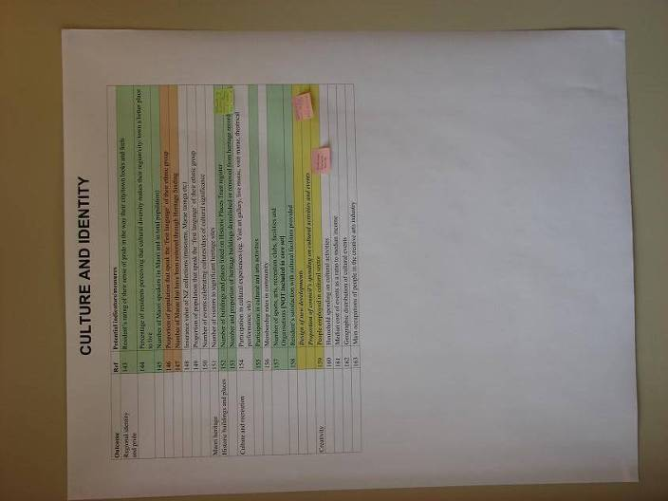
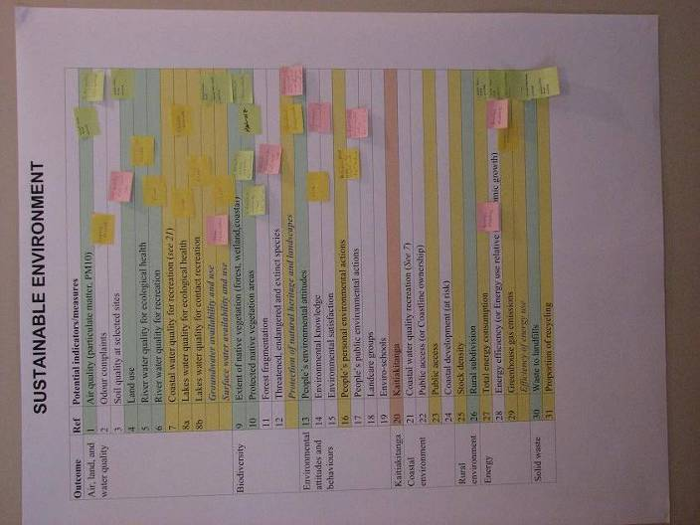
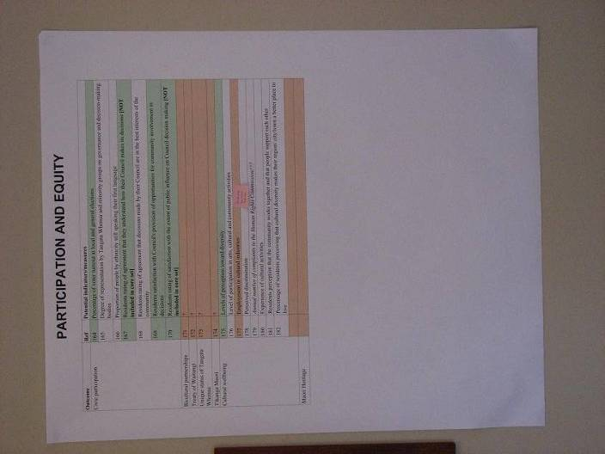
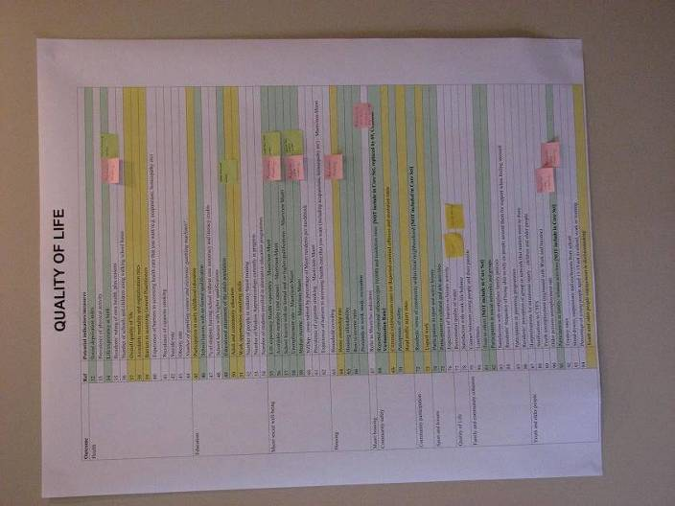
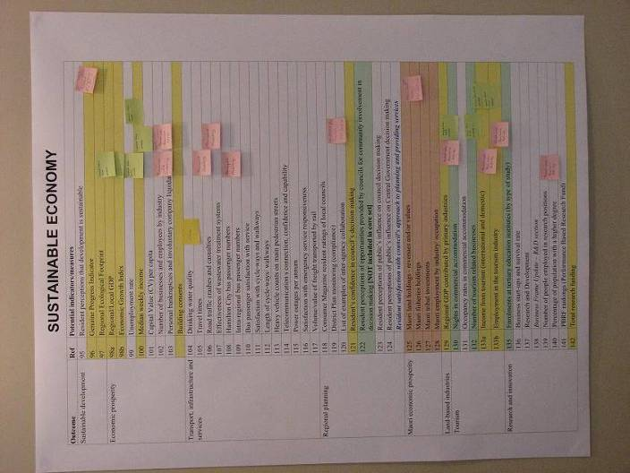
Fig 6. Results of the first workshop session showing links between potential SDSS components and MARCO indicators. The full set (200+) of indicators is depicted.

In the second session, workshop participants reviewed the qualitative scenarios developed as part of Objective 1. They listed the key drivers for each scenario and indicated which models may inform aspects of those scenarios. One group even went as far as putting together a simple system diagram to address their scenario.

After the two initial sessions, each presenter from earlier in the day provided a longer and more detailed discussion of their potential model components. As each organisation presented, the group collectively began to design an overall systems diagram that represented the first attempt at scoping the overall SDSS. By the end of the first day of the workshop, the first crude attempt at designing the overall SDSS has emerged (Fig. 6).

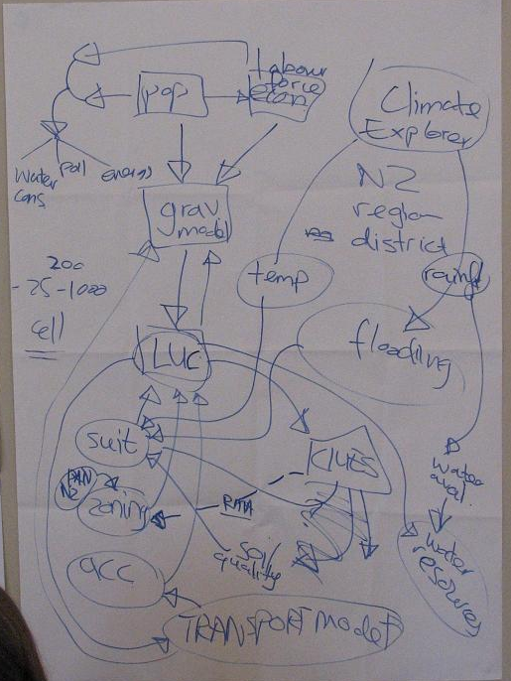
Fig. 6 First attempt at SDSS system design.

The second day of the workshop focused mainly on learning more detail about each potential contribution and identifying questions and gaps that arose from the initial design of the SDSS.

Draft SDSS Specifications

Overall System Design

Overview
The overall system design of the Choosing Regional Futures SDSS consists of a series of integrated model components that operate at four spatial scales: NZ & the World, the Waikato region, districts (e.g., Waipa, Matamata-Piako), and local, i.e. 200 m x 200 m grid cells (Fig. 7). Each model component represents more detailed sub-models, each of which vary in detail, data, and internal structure. Arrows represent links or flows among the different model components. The direction of the arrow shows the direction of flow. For example, the Demography model component generates information on population at the district level. Population is pooled among all districts to create a supply of labour to the Labour Market, which in turn supplies demand for workers from the Regional Economy.
The overall system diagram approximates as best as possible what the high-level system diagram will look like in the completed Waikato SDSS. It follows the general conventions and style used for similar projects developed within the RIKS GEONAMICA® framework. By following those conventions and styles, we hope to promote familiarity from the onset by exposing potential users to aspects of the finished SDSS as it is developed.
Below are short summaries of the model components at each of the five spatial scales. The following sections provide more detail on each of the model components.

NZ to Global Scale
The New Zealand to Global scale contains Climate Scenarios and External Drivers. These contain information on global conditions that act as drivers of change for New Zealand and by extension the Waikato region and member districts. The Climate Scenarios consist of pre-defined scenarios for climate change. The scenarios represent standard IPCC climate change scenarios that have been down-scaled for use at scales relevant to New Zealand. The External Drivers contain information on key drivers that may strongly influence New Zealand and/or the Waikato region. These variables could include factors such as foreign exchange rates, world commodity prices, interest rates, credit availability, migration trends, technological developments, etc.
A potential user could explore future scenarios based on different combinations of climate scenarios and assumptions about trends of the external drivers.

Regional Scale
The regional scale contains three model components: Waikato Region Dynamic Economy-Environment Model (WRDEEM), Hydrology, and Water Quality. WRDEEM is an adaptation of the Auckland Region Dynamic Economy-Environment Model developed by NZCEE and Market Economics through the Pathways to Sustainability FRST Programme. WRDEEM consists of six sub-modules: Population, Labour Force, Growth, Economics, Economic Physical Flow, and Environment-Economic Physical Flow. WRDEEM is a system dynamics model of region-wide environment-economy interactions. It models the flow of economic commodities as traded on markets in both monetary ($NZ₁₉₉₈) and physical terms (tonnes), along with the flow of associated natural resource inputs (e.g., land, energy, water) and residual outputs (e.g., wastes, pollutants and emissions). The model is designed to simulate the combined environmental and economic implications of economic change in the Waikato Region between 1998 (base year) and 2051. The model is driven by scenarios of economic growth. Hydrology is based on the TOPNET model. TOPNET simulates surface and shallow groundwater hydrology to generate hourly time series of river flow and soil moisture for the study area. Model simulations can cover periods of several years to decades. TOPNET also includes impacts of spatially varying climate, soil, vegetation and topography on hydrological response. The Water Quality submodel represents an adaptation of SPARROW model developed as part of the CLUES project. SPARROW estimates pollution loads, such as total nitrogen or total phosphorous, at a given point in the river network as a function of upstream catchment characteristics including land use.

District Scale
The District scale contains three model components: Zoning, Demographics, and Dairying. Zoning consists of zoning maps prepared by district and city councils as part of their district/city plans. The Zones outline areas where different land-use activities are or are not permitted. Zoning information directly affects the local-scale land use model (see below) by controlling where different land uses can and cannot occur.
The Demographics model component consists of the Population Studies Centre PROJECTIONS model. PROJECTIONS will model population over time, expressed as 1-year male and female age cohorts, for each district within the Waikato region. The model will estimate birth rates, death rates, and net migration rates from each district to other districts within the Waikato region, and from each district to outside the region.
The Dairying component models different levels of dairy intensity within each cell based on a combination of physical attributes or suitability, production targets (i.e. kg/milk solids/ha desired), and management practices.

Local Scale
The Local Scale consists of three model components: Land Use, Biodiversity, and Dairying as well as the potential to develop a number of Spatial Indicators. In the Waikato SDSS, the Waikato region will be represented as a grid of square cells (or pixels). Grid cell resolution can vary, and initially a resolution of 200 x 200 m will be used to try to model more detailed land use. A larger resolution, say 400 x 400 m, may be more appropriate, however, based on the expected use of the SDSS, as a finer resolution generates longer model run times and makes the SDSS less suitable for interactive use.
The Land Use model component dynamically models land use change over time based on demand for certain land uses generated at the district (Demograhic) or regional (WRDEEM – demand for land) scales and a combination of four other factors: Zoning (see above), suitability, accessibility, and local influence. Suitability estimates the biophysical suitability of land for different uses. For example, areas with steep slopes will not be suitable for certain types of agriculture. Accessibility typically relates to travel distances, which can affect the desirability of some land uses such as housing Local influence measures the influence of neighbouring land uses on a land use at a particular point. The four factors combined with regional demands change land use potential over time, resulting in land use changes.
The Biodiversity component tracks changes in indigenous and exotic vegetation over time. It combines information on vegetation with information on protected areas and the Land Environment of New Zealand (LENZ) terrestrial environmental classification to provide information on biodiversity status across a range of scales (local, district, and region). Changes in Land Use could affect Biodiversity both positively (restoration) or negatively (removal).
Different Spatial Indicators could be developed to track the status of different model inputs and outputs over time. Indicators would consist of a series of maps depicting indicators as they change (or not) over time. Land-use change over time is an example of a basic indicator that can be generated. The series of maps can be saved as an animated image and used for reporting, communication, and education purposes.
Fig. 7 Draft SDSS System Design
NZ & World
Region
District
Local
Waikato Region Dynamic Economy-Environment Model
NZCEE
External Drivers
External Sources
Water Quality
NIWA
Demography
UoW-PSC
Zoning
District Councils
Biodiversity
LCR
Spatial Indicators
Land Use
RIKS/LCR/EW
Climate Change Scenarios
NIWA
Dairying
UoW-SM
SUITABILITY
ACCESSIBILITY
LOCAL INFLUENCE
Hydrology
NIWA

GEONAMICA® Framework - RIKS
The Waikato SDSS will be developed and run under GEONAMICA®, an object-oriented application framework developed and supported by RIKS since 1990. It is especially tailored for developing Spatial Decision Support Systems featuring integrated dynamic models as their core element. It is an extendible toolbox containing ready to use software building blocks required for the development of models, analysis tools and user interfaces.
The GEONAMICA® DSS Generator
For the technical implementation, or software coding, of a Decision Support System the developer has essentially three types of products to choose from: a standard programming language, a DSS Generator, or a DSS specific application. Standard software languages do not need further elaboration. They are one of the state of the art general-purpose software programming languages such as: C++, Java, Delphi, or Basic. They provide maximum flexibility, but are low-level and difficult to master. To apply them for the development of a fair size, state-of-the-art DSS would take a very substantial investment in time and human resources. More attuned to the specific purpose are the so-called DSS-Generators. A DSS Generator is defined by Sprague and Carlson (1982) as “a package of hardware/software which provides a set of capabilities to build specific DSSs quickly and easily’”. Hence, this refers mostly to a special purpose software environment for the creation of new DSS applications in a more or less narrowly defined domain. In the business context, Microsoft Excel is often referred to as a DSS-Generator, because it is equipped with a standard set of functions and tools that are typically wanted in business-oriented DSS applications. Finally, a DSS can also be developed on the basis of a DSS specific application. The latter are off-the-shelf applications instrumental for the implementation of narrowly defined, standard problems. They come in a ready-to-use format, ready to be completed, possibly by the end-user proper, with the data and the specifics of a problem and the problem owner. Today, Spatial Decision Support Systems are still far too unique and too sophisticated to be built by means of DSS specific applications. There are simply none available as yet. Hence, what is left are DSS-Generators and general purpose programming languages.
GEONAMICA® is a DSS-Generator developed and supported by RIKS bv. In particular it is an object-oriented application framework for use by DSS developers. It is specifically tailored for developing Spatial Decision Support Systems featuring models that run at multiple spatial and temporal resolutions; typically, it will combine system dynamics models and cellular models for this purpose. In particular, use is made of different kinds of spatial interaction based models, different kinds of cellular automata models, multi-agent, or other kinds of rule-based models. It is equipped with highly efficient computational techniques and algorithms for addressing spatial problems, but also with additional analytical tools, visualization tools, and input, import, export and output tools. It is also equipped with a number of tools for interactive map manipulations, in particular: map editors and display tools for 1-D network and 2-D map objects; map comparison; and overlay analysis.
Model Building Blocks in GEONAMICA
The cornerstone of the GEONAMICA® application framework is the way in which it enables the DSS-developer to set up a new modelbase consisting of a set of exchangeable and interchangeable Model Building Blocks (MBB) that can be entered, exchanged, re-arranged and re-used in the modelbase of the DSS nearly as easily as Lego building blocks. The concept of MBB is not new or unique to GEONAMICA®; rather it has been implemented in different forms as part of many simulation and modelling frameworks.
In GEONAMICA®, a Model Building Block represents a part of a model: an action or process. Hence, it is a more or less complete model varying from a simple mathematical operator to a complete model consisting of coupled mathematical equations performing a large number of sophisticated calculations. Some MBBs may simply represent sources of information (i.e. entered from file), while others will transform information as it passes through them, and still others will simply communicate, in a synthetic manner, the outputs of the model to the user. Despite the fact that all these MBBs play different roles in the model, in object-oriented jargon, they are all specializations of the same abstraction, which is essentially an MBB capable of exchanging and transforming information.
Each MBB has two graphical representations in the user interface of the DSS:
- A rectangle (or box). A unique graphical object in the system diagram of the integrated model showing how the MBB relates and is connected to other MBBs in the integrated model. A user can know from this connection scheme where the MBB gets its input(s) from, and where it sends its output(s) to;
- Its user interface (UI), which presents itself as a dialogue window. The user interface gives the user read/write access to all the MBB specific parameters as well as the initial (input) values of its state variables. While a simulation is running, it enables read-only access to all the updated values of output variables. Entering data in dialogues is done in a manner that will support and protect the user to some extent, because each edit box in a dialogue window knows what type of data it should get from the user: a single number, a vector of numbers, a matrix, or a table (i.e. time series). For each type the appropriate editor is opened when the user clicks in the edit box. Moreover, values entered are only accepted if they fit within a predefined validity range.
Each MBB has its Documentation page in the Documentation system of the DSS. The page is accessible when the dialogue window of the MBB is opened (by pressing the F1-key or clicking in the dialogue window by means of the Context Sensitive Help cursor). This Documentation page gives technical information about the MBB and may include the mathematical expression(s), scientific references, the specification of the inputs and outputs, etc.
The MBB manages the memory for its parameters and its variables. An advantage of this design is that it makes the MBBs self-contained and independent. The inputs of an MBB are pointers to the memory location where the required output resides. As output X is always managed by the MBB producing that output X, the input points to a memory location managed by the MBB producing the output X. An MBB does not know what MBB it receives input from. It is the responsibility of the simulation engine to connect the inputs of the receiving MBB to the outputs of the producing MBB while executing an integrated model.
The tasks to be carried out by the MBB are separately described for the different phases the simulator can be in. Phases are: On read, Init, Step, and On write. The Step function of the MBB contains the software code that implements the mathematical model of the MBB. It specifies how each of the outputs of the MBB changes depending on the time, the current input values, and the current parameter values. Each MBB runs at its own pace. The Step function of the MBB is called by the simulation engine, it is executed, and the MBB tells the simulation engine when it should be called again. The MBB does not know about other MBBs as they are kept as independent of one another as possible. It is the responsibility of the simulation engine to keep all MBBs synchronized in time.
Libraries are repositories of MBBs. The entire definition of the MBB (its code, its graphical representation, its dialogue, its connectors) is stored in the MBB Library. When an MBB is included in a model, the block itself is not copied to the model; rather a reference to the block in the library is made. MBBs can be reused in the same model more than once. But MBBs and Libraries can be re-used in other applications equally well. The factual re-usability will depend largely on the process modelled and the level of generic applicability attained in the implementation. The RIKS products Coaster and Catcher are both MBB libraries: the former is intended for implementing watershed management related systems and the latter for integrated coastal zone management systems.
The GEONAMICA SDK (Software Development Kit) provides all the templates required to start a new application and a new library. Building an application, or to put it in other words, creating a modelbase and connecting the MBBs into an integrated model, is enabled by application-specific software specifying which MBBs are part of the application, and how they are interconnected (which inputs are connected to which outputs). This application is the so-called model.dll. Not all models have to be available as MBBs within the library in order to be integrated into an application. An external (existing) software model can become part of a GEONAMICA application via an adaptor MBB. This is done by means of an ActiveX Model Wrapper Component, which wraps the external model into a piece of software so that it looks from the outside like a GEONAMICA MBB, and thus can function within a model like all the other MBBs. The ActiveX Model Wrapper Component delegates most of the work to the actual external model, but performs some missing functionality, such as displaying and effecting the user interface or the conversion of data between the GEONAMICA framework and the external model. If the external model is developed according to the specifications of the COM/ActiveX component technology, hence is an ActiveX Model Component equipped with all the necessary interfaces, a specific Adaptor MBB can then integrate it directly into the application.
The user interface of a typical GEONAMICA application consists of a number of system diagrams with sensitive areas. The diagrams are graphical representations of the application. The MBBs, represented by rectangles, are the sensitive areas. They are connected to either more specific diagrams, representing the MBB at a deeper level of detail (when the sensitive area is connected to a SuperMBB), or to the user interface (the dialogue) of the MBB (when the sensitive area is directly connected to a single MBB). The user can navigate through the system diagram hierarchy by clicking the sensitive areas.
GEONAMICA.exe is the piece of software capable of loading a specific application and thus launching the Decision Support System. GEONAMICA.exe is a generic executable, and the integrated model is a project-specific model.dll. GEONAMICA.exe also features a set of cellular spatial models that perform operations on a grid representation of the region modelled. The most powerful of these are Cellular Automata models of the kind developed by White, Engelen and Uljee.
GEONAMICA.exe will also launch the toolbase and the databases of the application. While an application is running, the tools are automatically invoked as the result of user actions, or they can be purposely selected from the menu system of the DSS. Pre-processing and post-processing tools such as the Overlay-Tool and the Analyse-Tool are available as separate applications that are launched independently of GEONAMICA.exe.
Finally, it is the GEONAMICA.exe that contains the information relative to the user rights defined in the license of the user.

Climate Change Scenarios- NIWA
- Name of model CLIMATE CHANGE SCENARIOS
- Organisation NIWA
- Contact: Andrew Tait, NIWA, Hamilton
- Status: In progress – Waikato and New Zealand Based
- Spatial Resolution: Regional
- Temporal Resolution Daily and annual
- Input Data Required Spatial
- Internal Data Required Nil
- Output Data Spatial

Model Summary
Two main ‘levels’ of information can be provided. Both are based on a statistical downscaling technique, rather than the regional climate model approach. They are described in the following section.

Model description
The first technique, projected changes in rainfall and temperature (plus some other variables), are generated from several GCMs (Global Climate Models) using different emissions scenarios for different future periods (e.g., 2021–2050 and 2071–2100). These are snapshot projections from a base period of 1971–2000 (see example below). The spatial resolution of these climate change projections is 5 km (based on statistical downscaling of GCM surface pressure fields).

The second involves application of the above scenarios to gridded daily historical data for all of NZ. This process produces future daily time series data for every 5 km for all NZ. So far we have produced time series of rainfall, maximum and minimum temperature, and PET. These data were used in the MfE drought report, for example. See:
http://www.climatechange.govt.nz/resources/reports/drought-risk-may05/index.html
These two climate change scenario formats have been used in several projects. However, should a specific model require scenarios in a slightly different format (e.g. applied to output from a weather generator), NIWA could conceivably produce these data as well.

Links to other models
The climate change scenarios provide information to TOPNET hydrological model (see next section), and could also provide data for the CLUES package.
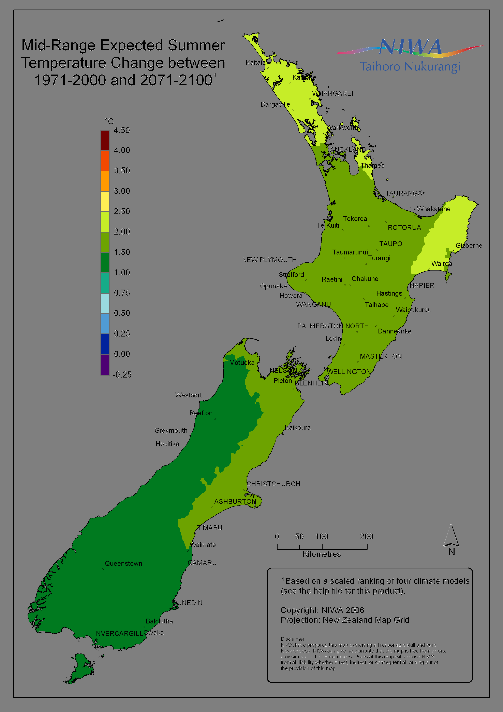

Fig 8. Example of a climate change scenario map showing the mid-range expected summer temperature change for New Zealand between 1971-2000 and 2071-2100.

Hydrology - NIWA
- Name of model Topnet
- Organisation NIWA
- Contact: Ross Woods, NIWA, Christchurch
- Status: In progress – catchment and regional
- Spatial Resolution: Varies with user need – typically 1–10 sq km sub-catchment
- Temporal Resolution Hourly, or daily with built-in disaggregation to hourly
- Input Data Required: Time series of spatially-distributed daily (or hourly) rainfall & temperature, e.g., from Model 5 above: Climate Explorer
- Internal Data Required: Topography, Soils, Vegetation, Land use
- Output Data: Spatial and temporal information on numerous surface water fluxes

Model Summary
Topnet is a hydrological simulation model for surface water and shallow groundwater. It includes the impacts of spatially varying climate, soil, vegetation and topography on hydrological response. The outputs of Topnet include hourly time series of river flow and soil moisture for many locations throughout the study area. Model simulations can cover periods of several years to decades.

Model description
Topnet resolves hydrological processes by dividing them into water balance processes and routing processes. Water balance within a subcatchment is modelled using modules for water that passes through the snowpack, plant canopy, surface runoff, root zone, and shallow saturated zone. Each subcatchment discharges runoff to a different point in the river network, and water is routed through the branched network using kinematic wave routing. The model is described in Bandaragoda et al. (2004). A sample application in New Zealand is described in Woods and Henderson (2004).

Topnet’s spatial discretisation subdivides the study area into subcatchments whose size is selected by the model builder. Within each subcatchment, the soil and vegetation properties are assumed to be uniform, and topography is assumed to drive within-catchment spatial variability, using a variant of the Topmodel approach. In New Zealand the River Environment Classification network provides a practical basis for this subdivision. Subcatchments could be as small as 1 sq km on average, or perhaps as large as 10 sq km. Any larger size would fail to resolve important spatial gradients.

Topnet’s internal calculations typically operate at hourly timesteps. If only daily climate data is available, Topnet can disaggregate to hourly timesteps. The model output is produced at the same hourly timestep, although it can always be aggregated later.

The inputs needed to run Topnet are
- Climate time series throughout the study region
- Catchment spatial data for elevation, soils, vegetation – this has already been assembled for all New Zealand, but new scenarios for land use could be prepared. If land-use scenarios are defined on a grid, an overlay process will be needed to convert these to sub-catchment values
- A control file specifying the start and end of the model run, and the source of climate data to be used

The Topnet model can produce output files for every modelled water flux and storage in each subcatchment or river reach, at every hour of the model run. These output files are usually very voluminous, and only a subset of the outputs is required for any particular model.

Links to other models
Topnet can use the climate change scenario data described above.
Topnet reads and writes data files in a binary format known as netcdf (http://www.unidata.ucar.edu/software/netcdf/). Interfaces to netcdf are available in many programming languages. These can facilitate the use of modelled river flow or soil moisture information in other “downstream” models.

Waikato Region Dynamic Economy-Environment Model – NZCEE

- Name of model Waikato Region Dynamic Environment-Economy Model (WRDEEM)
- Organisation New Zealand Centre for Ecological Economics
- Contact: Ross Woods, NIWA, Christchurch
- Status: Complete
- Spatial Resolution: Region
- Temporal Resolution Annual from 1998 to 2100
Validated using data from 1970 to 2005
- Input Data Required: Socio-economic statistical time series data for fertility Mortality
Net migration
Labour force participation rate
Employment by industry distribution
Rate of capital investment
Rate of capital depreciation
Technological change by industry
- Internal Data Required: None
- Output Data: Population, labour force
Employment
Unemployment
Economic growth
Economic commodity production and consumption (in both monetary and physical flow terms)
Gross Regional Product
Balance of Trade
Natural resource physical inputs and residual physical outputs (as outlined below)

Model Summary
WRDEEM is a system dynamics model of region-wide environment-economy interactions. It models the flow of economic commodities as traded on markets in both monetary ($NZ₁₉₉₈) and physical terms (tonnes), along with the flow of associated natural resource inputs (e.g., land, energy, water) and residual outputs (e.g., wastes, pollutants and emissions). The model is designed to simulate the combined environmental and economic implications of economic change in the Waikato Region between 1998 (base year) and 2051. The model is driven by scenarios of economic growth.

The purpose of the model is not to predict Waikato Region’s economic future, but rather to highlight possible physical and economic consequences under various scenarios. A key reason for the adoption of a system dynamics modelling framework is that it allows a great deal of flexibility in setting the scenarios that may be investigated. The scenarios themselves are designed to capture not only the ‘business as usual’ situation, but also the dynamic physical and economic consequences resulting from more extreme change.

Model Description
The WRDEEM model consists of the following interconnected modules (Fig. 9):
Fig. 9 WRDEEM Module Linkages

- Labour force module. This module takes outputs from the population module by age-sex cohort and generates estimates of total labour force, employment and unemployment by industry.
- Growth module. This module generates estimates of economic output by industry. The cornerstone of the growth module is a Cobb-Douglas production function with constant returns to scale. The production function has the following factor inputs: employment (as generated by the labour force module), commodity imports and use (from the economic flow module), and manufactured capital stocks. The production function is augmented with indices representing technological change and natural capital depletion/degradation. The output estimates generated by this module feed into the economic flow and economic physical flow modules.
- Economic flow module. This module describes the financial flow of commodities within the Waikato Region economy including commodity supply, use, imports and exports. The module provides inputs for the growth and economic physical flow modules and generates key economic aggregates including GRP, balance of trade, labour productivity, capital productivity and so on.
- Economic physical flow module. This module describes the Waikato Region economy in physical (mass) flow terms, including commodity supply, use, imports and exports, and is closely related to the economic flow module. The focus of the module is on the within-economy physical flows. Monetary estimates of commodity supply and use from the economic flow module are converted into physical equivalents based on price ($ per tonne) and indices of improvements in physical productivity.
- Environment-economy physical flow module. This module describes the physical flow of raw materials and residuals associated with economic activity in the Waikato Region. The focal point of this module is the physical flow of ecological commodities not conventionally measured in economic markets. To generate estimates of the physical flow of raw materials and residuals, the module draws on the output by industry estimates generated by the growth module, exogenous estimates of raw material use/residual generation per $ output, and indices of improvements in physical productivity.

Each module is discussed in further detail below with particular reference given to the key inputs and outputs.

Population Module
The Population Module disaggregates Waikato Region’s population by sex and 5-year age cohorts (i.e. 0–4 years, 5–9 years … 75–79 years, and 80 years and over). Birth and mortality rates are calibrated using time series data covering the period from 1970 to 2001. Estimates of migration are based on Statistics New Zealand’s sub-national projections. The Population Module is shown as a system diagram in Fig. 10.

The key output from the Population Module is population by sex and 5-year age cohort.

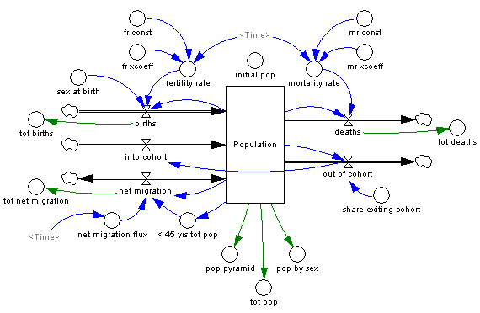
Fig. 10 Population Module System Diagram.

Labour Force Module
This module converts the population module estimates into total available labour force (> 15 years of age); adjusts these estimates for unemployment to derive full-time equivalent (FTE) employment; and distributes this employment across 30 economic industries. These employment-by-industry estimates are a critical factor input into the economic production functions of the growth module. The Labour Force Module is shown in Fig. 11.

Key outputs from this module include labour force, employment and unemployment estimates by sex and five year age cohort and employment by economic industry.

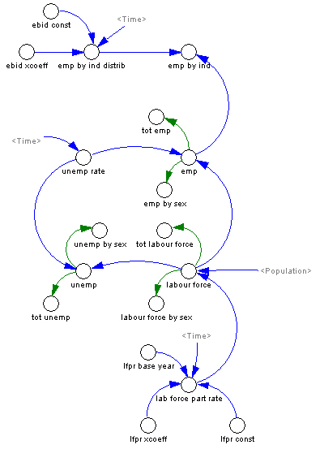
Fig. 11 Labour Force Module System Diagram

Growth Module
Central to the operation of WRDEEM is the use of economic production functions that provide estimates of future output by industry within the Waikato Region economy (Fig. 12). These production functions are comprised of factor inputs (i.e. manufactured capital, natural capital, labour, domestic commodity use, commodity imports, and technological change), which are determined through a number of dynamic feedback loops.

Key outputs from this module include economic output by industry, the stock of manufactured capital, labour inputs (measured in hours worked), labour and capital productivity, rates of capital investment and depreciation and technological change.

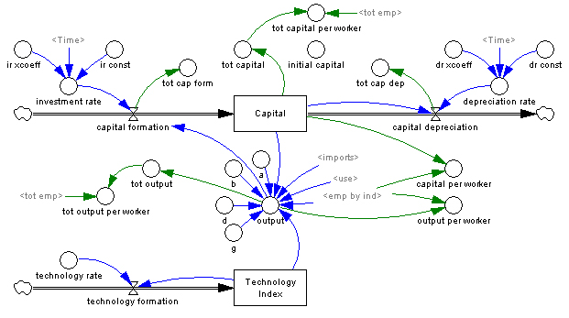

Fig. 12 Growth Module System Diagram.

Economic Module
The Economic Module describes the Waikato Region economy in terms of the flow of commodities supplied both domestically and internationally, and their corresponding use and final consumption (Fig. 13). Critical to the operation of this model is the determination of inter-industry interdependencies. The module is linked with the growth module through a number of positive (reinforcing) feedbacks. On the one hand, it provides key inputs into the growth module by generating estimates of (1) commodity imports required to satisfy both intermediate and final demand, and (2) intermediate demand commodity use. On the other hand, it utilises estimates of output and capital formation in the calculation of interregional exports, international exports and other final demands (e.g., capital formation).

There are several key outputs of the Economic Module, many of which may be reported for each of the model’s 30 economic industries. These include GRP, Balance of Trade (BOT), domestic production and imports of commodities, and on the flip-side, domestic (household) consumption and exports.
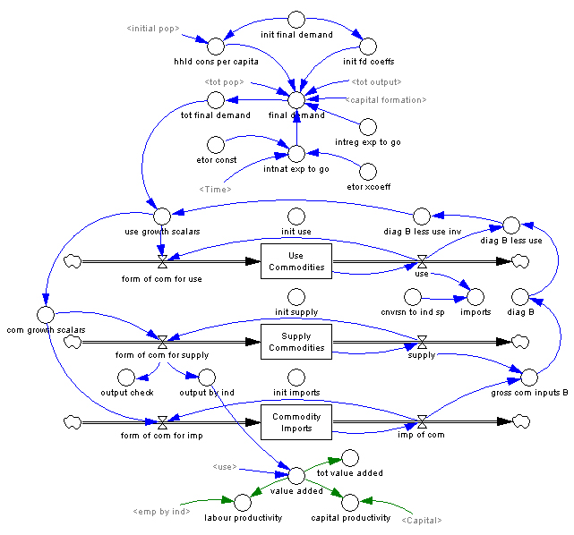
Fig. 13 Economic Module System Diagram.

Economic Physical Flow and Environment-Economy Physical Flow Modules
The Economic Physical Flow Module is the physical equivalent of the Economic Flow Module. It describes the Waikato Region economy in physical (mass) flow terms, including commodity supply, use, imports and exports. The module focuses purely on the within-economy physical flows. Similarly, the Environment-Economy Physical Flow Module describes the physical flow of ecological commodities (raw materials and residuals) associated with economic activity in the Waikato Region. Table 6 provides a list of the raw materials and residuals captured within this module.

Table 6 Raw Materials and Residuals Included in the Environment-Economy Physical Flow Module

Key outputs of theses modules include economic commodity flows measured in physical terms (i.e. tonnes), natural resource inputs into each industry of the Waikato economy, and associated residuals.

Links to Other Models
WRDEEM is closely linked with several other models within the project, including:

- Demographics (University of Waikato, Population Studies Centre Population Models). The multi-region single year cohort model of the UoW represents an improvement of the Population Module contained within WRDEEM. It is therefore recommended that this model replace the Population Module contained WRDEEM.
- Cellular Automata Dynamic Land Use Change Model (RIKS). This model utilises population, labour force and economic growth rates, at both national and regional levels, to simulate land use change through time. To date, RIKS has relied on static models (typically input-output tables) as the basis for distributing economic growth across industries. The dynamic growth and economic flow modules of WRDEEM are a significant advancement over the static input-output modelling approach.

Water Quality – NIWA
- Name of model CLUES (Catchment Land Use for Environmental Sustainability)
- Organisation NIWA, with contributions from Landcare Research, AgResearch, HortResearch, Harris Consulting
- Contact: Graham McBride, NIWA, Hamilton
- Status: In progress – Waikato and New Zealand Based
- Spatial Resolution: Sub-catchment (10 km² and above)
- Temporal Resolution Average annual
- Input Data Required Spatial
- Internal Data Required Presently uses a national calibration dataset; will be extended to cater for local calibration
- Output Data Spatial

Model Summary
The models in the CLUES package are aimed at explaining and predicting annual loads of nutrients from present and future distributions of point sources, climate, and land uses. The core model is SPARROW (Spatially Referenced Regressions on Watershed attributes), developed in concert with the United States Geological Survey, and calibrated to data from the National Rivers Water Quality Monitoring Network. This core is enhanced by other models: OVERSEER®, for local estimates of nutrient leaching in agricultural areas; SPASMO, for leaching of nutrients under horticultural land use; and TBL (Triple Bottom Line) for farm economics. Estimates of nitrogen leaching risk are also made via the Ensus model. Ongoing development will result in the inclusion of sediments and microbes in the package and other enhancements.

Model description
The essential structure of the CLUES package is shown in the following diagram.

Fig. 14 Conceptual diagram of the CLUES model.
The SPARROW model accounts for “Routing, Accumulation, decay”, and infers contaminant losses. Its spatial surface has been implemented on NIWA’s River Environment Classification database, at 30-m grid resolution, on which stream/lake/reservoir locations were burned in. The resulting national model has nearly 600 000 reaches. Data for concentrations of Total Nitrogen and Total Phosphorus collected from the 77 sites in NIWA’s National River Water Quality Monitoring Network were combined with river flow information from those sites to make estimates of annual loads. The model was calibrated against these data, i.e. by adjusting its coefficient to optimise the match with the calculated loads. In doing so, it used information on: (a) point sources of nutrients (from Regional Council data, consultancy reports, and informed estimations), (b) land use (combining data from AgriBase (AgriQuality) and the LCDB2 (Land Cover DataBase), (c) mean stream flow, using rainfall and evapotranspiration modelling. The model’s structure allows calibration not only of the contribution of point sources and land uses, but also delivers land-to-water delivery variables (e.g., rain, drainage efficiency) and in-stream attenuation (“decay”). An implementation for the Waikato region has been reported (Alexander et al. 2002).
SPARROW has two very desirable properties that give enhanced credence to its results:
- it is “data hungry”: it demands and uses large quantities of environmental data of many types
- while statistical in nature (the model coefficients are largely unconstrained, and are optimised by the model fitting procedure during calibration), its coefficients are physically interpretable. For example, it produces settling rates for reservoirs and these can be checked for physical plausibility against other, local and independent settling studies.
Finally, the model’s output can calculate yields at any point on the landscape, and it can also present fraction of the load delivered to any downstream point, highlighting the relative importance of all upstream sources.
The structure of the model is shown below (Fig. 15). Full details for its latest application (to the whole New Zealand landscape) have been reported by Elliott et al. (2005).

Fig. 15 Structure of the SPARROW model.

In CLUES, the contaminant loss models are augmented with predictions made by:
- OVERSEER® (Agresearch), calculating nitrate leaching from data on catchment, soils, climate and stock density. As presently configured, it is in the form of a DLL (Dynamic Linked Library), not as source code. It has been calibrated on local leaching studies and, in its present form, can be applied to dairy, lowland sheep/beef, hill country sheep/beef, high country sheep/beef, and deer.

- SPASMO – Soil Plant Atmospheric System Model (HortResearch). This is a complex model running on daily time-steps. Its incorporation into CLUES has been simplified by performing many simulations for five crops (apple, grape, kiwifruit, onion, and potato) at 12 climate stations and standard fertilising regimes, and building from that a “look-up table” for annual nitrogen budgets. SPASMO is not yet fully integrated into CLUES, but is to be extended to another crop (maize/sweet corn)

- TBL (Harris Consulting). Statistical equations have been developed to mimic gross output (in $) per hectare, Cash Farm Surplus, Total GDP and Total Employment. At present there are arable and horticultural components; forestry and tourism components are to be added.

- ENSUS (Landare Research). A national map of soils and land use has been developed, along with a map of nitrate leaching risk model obtained from a combination of a vulnerability index and a pressure index.

Links to other models
CLUES is being developed as a stand-alone model package, though constituent elements could, in principle, be extracted for particular uses. As presently configured, it does not link directly to other models.
The SPARROW component of CLUES is freeware, and software is available, in SAS (see details at http://water.usgs.gov/nawqa/sparrow/).

Zoning – District Councils via EW
- Name of model Zoning
- Organisation District Councils via Environment Waikato
- Contact: Derek Phyn
- Status: Varies according to districts
- Spatial Resolution: Subdistrict – land use zones based on District Plans
- Temporal Resolution Zoning can change up to twice within the GEONAMICA framework
- Input Data Required Current District council zoning maps; future zoning changes also possible
- Internal Data Required None
- Output Data Maps of land-use zones

Model Summary
The Zoning component contains a series of maps, one for each land use, indicating which land uses are or are not allowed at within each district local. Zoning will be based on a compilation of information from District Council within the region as well as information on protected lands generated for use in the Biodiversity model discussed below. Zoning can be static (does not change) during the model simulation or it can change up to twice based on user-defined input.

Model Description
Land-use zones are represented as polygons on a map (Fig. 16). For the purposes of the SDSS, the polygons would be rasterized or depicted as grid cells for direct links with the Land Use Model.

Links to other models
Zoning links to the Land Use Model by specifying which land uses may occur in which locations. More technically, the zoning controls land-use land change by weighting overall transition potential by 0 (not allowed) or 1 (allowed).

Fig. 16 Zoning map from the Hamilton City Council Proposed District Plan (Map No S22). Zone legend: white = Residential; green = Recreation; red = Commercial Services; dark blue = City Centre, light blue = Suburban Centre; Dark blue areas Purple areas are Community Facilities Zones. Blue diagonal stripes = High Density Residential Area. Green Cross Hatch = Commercial Service Special Amenity Area. Black stipples = Environmental Protection Overlay. Map available at http://data.hcc.govt.nz/District_Plan/DPC/S22.pdf.

Demographics – University of Waikato, Population Studies Centre
- Name of model: PSC Projections
- Organisation: Population Studies Centre, University of Waikato
- Contact: Professor Jacques Poot
- Status: Model complete; parameter availability varies by region
- Spatial Resolution: District Council
- Temporal Resolution: Annual
- Input Data Required: Population information at start of simulation
- Internal Data Required: Birth, morality and emigration rates by 1-year age cohorts for each district
- Output Data: Population estimates by 1-year age cohorts for each district

Model Summary
The PSC projections model generates possible future populations, referred to as population projections, starting from a given base population and from assumptions about the demographic processes of fertility, mortality and migration. The methodology used is that of the standard cohort-component model also widely used by other agencies, including Statistics New Zealand and RIKS. Differences between agencies in reported projections are solely the result of different assumptions used about fertility, mortality and migration behaviour. Population projections can be calculated at different scales (urban area/region/nation) and also form the basis of projections of households, the labour force and ethnic composition. For population projection at a sub-urban scale (area unit), a different methodology is used. The model has already been applied to provide population projections for the Hamilton City Council (Cameron et al. 2007)

Model Description
The most common methodology for population projections is the cohort-component model. This is the methodology used by Statistics New Zealand (SNZ), which is the major supplier of data on current and projected population size, growth and structure for New Zealand regions and districts. In recent years new methodologies have been developed for population projections, such as stochastic and microsimulation approaches (see e.g., Dharmalingam & Pool 2005). However, these methodologies are highly data and computing intensive. We adopt the conventional cohort-component model instead, because this approach allows readily a comparison between alternate projections and the official projection series. This methodology is also appropriate given limited available data.
Fig. 17 describes the general approach used in population projections. The current population (base population) is first defined, and then assumptions are made about demographic changes to this population, using the cohort-component model. This is a stock-flow model based on the following fundamental “accounting identity” of population growth:
usually resident population in area i at the end of year t =
usually resident population in area i at the beginning of year t
+ births to mothers residing in area i during year t
– deaths of residents of area i during year t
+ inward migration from other regions and from overseas into region i
during year t
– outward migration of residents from area i to other regions or to overseas
during year t
Starting with a given base year population, the population 12 months later is then calculated with the equation above. This defines the base population of the following year. This procedure is repeated for each year through to the end of the projection period. This is done for both genders. Separate assumptions are used for each of the demographic “drivers”. Births are derived by multiplying age specific fertility rates by the numbers of women of childbearing age (13–49). Deaths are derived by multiplying age- and gender-specific mortality rates by the numbers of people of each age and gender. In basic projections, inward and outward migration are combined into age-sex specific levels of net migration.

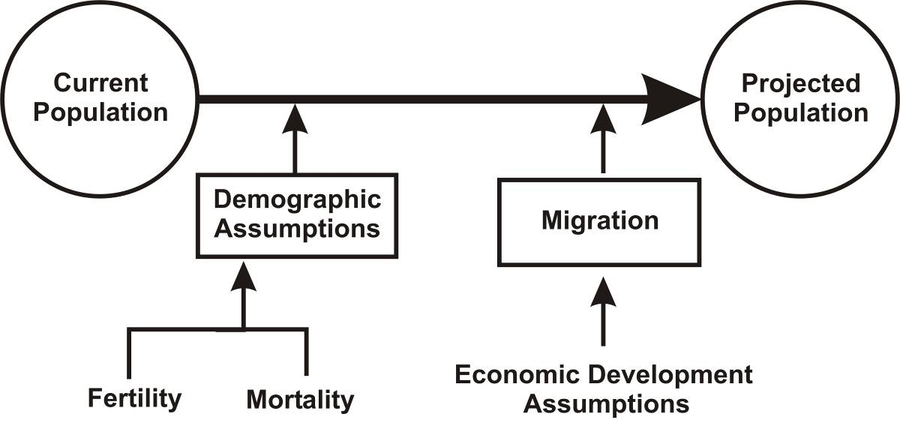
Fig. 17 Conceptual model of the end-user informed POPULATIONS cohort-component model.

The impact of economic development on net migration, using, for example, forecasts of labour demand derived from a regional input-output model, can be taken into account. The combination of demographic change assumptions and development assumptions, when applied to the current population, allows the calculation of possible future populations. Such calculations are referred to as population projections rather than population forecasts, because they depend on sets of assumptions and no explicit assessment is made of the relatively likelihood of the assumptions being correct in the future. Varying the assumptions across projections simply permits a sensitivity analysis that provides a relatively broad range of possible outcomes.
This methodology is less appropriate for population projection at a very small geographical scale, such as an area unit in census terminology. At this level, migration is the major determinant of population change and needs to be forecast separately. Various statistical methods are available (see, e.g., Tayman & Sawnson 1996; Simpson et al. 1998, Chi & Voss 2005). One methodology, used for local area projections for Hamilton city, takes the number of dwellings and the possibility of new dwelling construction (infill housing) and changing microdensity (number of persons per household) into account, combined with the existing distribution of population across area units and the projected population at the aggregate level in formulating plausible change in existing suburbs.
Moving from population projections to household projections and labour force projections, assumptions are made on changes in the distribution of household types and age-sex specific labour force participation rates. Ethnic projections are carried out separately for major ethnic groups and take into account inter-ethnic migration based on self-identification with one or more ethnic groups.

Links to Other Models
There is a three-way interaction between population, the economic system and the ecological system, but population projections are often considered exogenous inputs into models of economic activity, resource use and environmental impact. The reason for this is that the processes that affect fertility and mortality are very complex. While quantitative estimates of, e.g., income on fertility – or air quality on mortality – exist, they vary widely. Demographic processes are also seen as exhibiting relatively slow dynamics, so that particularly for short- to medium-terms forecasting, the assumption of exogenous natural increase is considered reasonably sound. With respect to migration, however, differences across regions in economic growth do affect net migration. Gravity models of gross migration that take account of the differences in population scale and economic across regions have been successfully applied in New Zealand in the past (Poot 1986; Mare & Timmins 2004). However, cohort-component models use exogenous assumptions of net migration by age and sex for each region that are developed for each region. Such models only need to satisfy adding up constraints that (1) the aggregate across regions of net internal migration is nationally zero for each age and sex group), and (2) the aggregate across regions of net international migration by age and sex must be the same as the net international migration assumption used for national population projections. While it is in principle possible to develop a multi-regional demographic-economic interaction model with endogenous migration, this is beyond the scope of the CRF project.

Dairying – University of Waikato, Department of Economics
- Name of model: Waikato Dairying Model
- Organisation: Waikato Management School
- Contact: Professor Frank Scrimgeour
- Status: Model under development; complete for several districts within the region but full implementation requires further development and parameter estimation for all districts
- Spatial Resolution: Farm scale aggregated to district level
- Temporal Resolution: Annual
- Input Data Required: Cow numbers/farm, number of herds/farm, predominant breed type, farm size (hectares), milk solids produced per farm per year (kg/year), soil type, topography, drainage, fertiliser use (N, P, K as kg/hectare), supplementary feeding, feed cost, fertiliser cost, capital cost, energy (feed content, fertilizer, electricity, fuel), energy content of outputs
- Internal Data Required: Individual farm model parameters
- Output Data: Farm revenue, farm profits, farm input expenditures, livestock numbers, nitrogen emissions

Model Summary
The University of Waikato Dairy Model has several purposes:

- To understand the economic impact of dairying on the Waikato and NZ economies. This includes understanding of profits, value added and related concepts but also impacts on related sectors in terms of both inputs and output related effects
- To understand the impact of economic, political and other shocks and trends on the Waikato dairy industry
- To understand the impact of the Waikato dairy industry on water consumption, pollution and the state of the environment more generally.

Model Description
The Waikato Model is built on a foundation of models of individual dairy farms, aggregated to achieve results that are valid for territorial authorities. Testing with the DEXCEL farm model validates the results. The model is currently being adapted so that it can be applied to individual catchments.

The current status of the work is that the University is generating results for three Territorial Authorities. The work needs focused attention to apply the analysis to all Territorial Authorities in the region. Related work has made significant progress in using these models for analysing economic and environmental impacts of alternative regulatory policies. So far six papers have been written and presented at conferences. Two are under consideration with international refereed journals.

Links to Other Models
The Waikato dairy model would link to the WRDEEM model by thorough estimation of economic inputs and outputs, resource use, and waste generation, principally nitrogen. It would also potentially link to the Water Quality Model by providing estimates of nitrogen emissions to surface water runoff.

Biodiversity – Landcare Research
- Name of model Ecosystem Representativeness
- Organisation Landcare Research
- Contact: Daniel Rutledge
- Status: Complete
- Spatial Resolution: 25-m grid cells (finest resolution)
- Temporal Resolution Varies according to update frequency of underlying data
- Input Data Required Land use/land cover; protected areas; Land Environments of New Zealand
- Internal Data Required None
- Output Data Spatially explicit database of ecosystem representativeness including information on protected areas and threat status of land environments

Model Summary
The ecosystem representativeness model performs a combinatorial analysis to identify unique combinations of land environments, protected areas, and land use/cover. That information in turn generates information on ecosystem representativeness and threat categories of land environments as part of key information needed for assessing progress towards the goals of the New Zealand Biodiversity strategy.

Model Description
The New Zealand Biodiversity Strategy broadly calls for actions to halt the decline of indigenous biodiversity throughout New Zealand. The Strategy specifically promotes two major goals for indigenous biodiversity:
- Maintain and restore the full range of remaining natural habitats and ecosystems to a healthy functioning state, enhance critically scarce habitats, and sustain the more modified ecosystems in production and urban environments
- Maintain and restore viable populations of all indigenous species and subspecies across their natural range, and maintain their genetic diversity.
Because the full state of biodiversity across all New Zealand is not – or never will be – fully known, we rely on indicators to help assess our progress in achieving such goals (Lee et al. 2004).
The Biodiversity model combines information on all land uses including vegetation state with information from two other primary data sources to produce an indicator of ecosystem representativeness. The two data sources are information on land environments that serve as surrogates for ecosystems & habitats (Land Environments of New Zealand or LENZ) (Leathwick et al. 2003, b) and a database of legally protected areas (Protected Areas Network of New Zealand or PAN-NZ) (Rutledge et al. 2004; Walker et al. 2005) (Table 7). The model overlays information on vegetation state generated by the SDSS with LENZ and PAN-NZ to generate a new spatial data layer whose values consist of a reference to a look-up table containing all unique combinations of vegetation state, LENZ environments, and protected areas. Based on the results of the combinatorial analysis, the model then assigns each environment to 1 of 5 threat categories (Walker et al. 2006) based on the level of remaining native vegetation and amount of legal protection (Table 8).
Table 7 Spatial data layers used in the Biodiversity model to analyse ecosystem representativeness
Layer | Source | Classes | Description
Land Use | SDSS | Native (1) | Vegetation – Native, Water, Bare Ground, Wetlands
 |  | Exotic (0) | All other land use classes
Land Environments of New Zealand (LENZ) Level IV Version 1.0 | Ministry for the Environment | 1–500 | Layer depicting areas with similar environmental conditions across New Zealand based on a combination of climate, landform, and soil conditions
Protected Areas Network of New Zealand (PAN-NZ) | Landcare Research  (compilation of other data sources) | Protected (1) | Legally protected areas based on polygon coverages supplied by:  - Conservation Estate (DOC managed)  - Queen Elizabeth II National Trust  - Nga Whenua Rahui  - Nature Heritage Fund  - Regional Councils
 |  | Not Protected (0) | All other land

Links to Other Models
The Biodiversity model has links directly to the Land Use model in that changes in land use, particularly loss of vegetation, affect the calculation of ecosystem representativenss. Zoning indirectly links to the Biodiversity model by defining protected areas where development cannot occur.
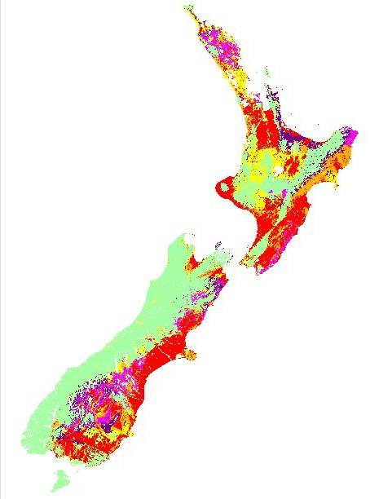
No threat category
Chronically Threatened
Critically Underprotected
Acutely Threatened
At Risk
Underprotected
THREAT CATEGORY
A.
Fig. 18 Distribution of threatened environments across New Zealand (after Walker et al. 2006)

Table 8 LENZ environments threat categories, and defining criteria (after Walker et al. 2006)
Category | Criteria
 | Vegetation - Native | Legal Protection
Acutely Threatened | <10% | 0–100%
Chronically Threatened | 10–20% | 0–100%
At Risk | 20–30% | 0–100%
Critically Underprotected | >30% | <10%
Underprotected | >30% | 10–20%
No Threat Category | >30% | >20%

Land Use – RIKS
- Name of model Cellular Automata Dynamic Land Use Change
- Organisation RIKS
- Contact: Hedwig van Delden
- Status: On-going development
- Spatial Resolution: Varies based on user needs but generally from 100 m to several kilometre grid cells
- Temporal Resolution Varies based on user needs but typically annually
- Input Data Required Land use, land-use suitability, zoning, accessibility, influence matrix; land use demand from regional environment model
- Internal Data Required Transition potentials calculated as part of model run
- Output Data Land-use layers at each model time step

Model Summary
The Land Use Model determines land-use dynamics over time at the grid cell (individual pixel) level within the SDSS. The model assesses the transition potential for each cell based on a combination of 4 key attributes: zoning, suitability, accessibility, and local influence. Demands (hectares of land required) for certain land uses (residential, commercial, etc.) can be set externally by the user or other model components within the SDSS. Grid cells change to the land use with the highest potential until those external demands are met.

Model Description
The Cellular Automata Dynamic Land Use Change model evaluates land-use dynamics over time, typically annually, within a simulation run. Land use change evaluates transition potential based on a combination of:

- Land Use Suitability (for land use functions or vacant states – see below)
- Zoning (for land use functions or vacant states – see below)
- Accessibility (typically distance to roads but distance to other features also possible)
- Influence Matrix – distance rules between each pair of land uses that affect the transition potential.

Table 9 summaries the data required to develop the LUC model, identifies the lead organisation for data development, lists likely data sources, and provides any comments on data development. At a minimum the land-use model requires the land-use classification layer and the influence matrix to run. Including data layers for suitability, zoning, and accessibility will take full advantage of the model’s potential by including a more full range of factors that influence land-use decisions.

Table 9 Land-use modelling data development
Spatial  Data Layer | Lead Organisation | Data Source(s) | Comments
Land Use Classification* | LCR  EW assist | Land Cover Database  Topomap  Aerial Photos  Cadastral Database  Consents Database?  Agriquality? | Will require a combination of several data sources to produce; the process should rely on readily available data sources to guarantee that the data could be generated elsewhere in NZ without substantial additional cost
Land Use Suitability | LCR lead  Other team members assist as needed | LENZ  NIWA Climate Layers  Land Resource Inventory  National Soils Database  Others… | Required data sources will vary depending upon the set of land use classes used and the degree of complexity/sophistication (see below)
Zoning | EW | District Councils | Discussed as part of the district scale models
Accessibility | EW | Road and Highway Networks from LTNZ | Simply requires supplying transportation network to RIKS, including existing and planned roads and highways
Influence Matrix* | RIKS Lead  LCR & EW assist | Land use at one and ideally two or more time steps | If two or more land use time steps exist, then calibration (either manual or semi-automatic) is possible; otherwise influence matrix is generated based on expert judgement
*Essential data for the running the land-use model

Land Use Classification Layer

Within the model, land use occurs as one of three types: functions, vacant, or features (Table 10). Functions and vacant land uses are subject to somewhat different micro-scale dynamics, while features do not change at all during the course of the simulation.

Table 10 Types of land-use classes within RIK’s Cellular Automata Land Use Change model
 | Dynamics at
Land Use Type | Local Level | Regional  Level | Type of Microdynamics | Dynamics determined by
Function | Yes | Yes | Active | Dynamics at Regional Level sets overall demands (ha) required; Local Level Dynamics (CA Model) allocates land use until Regional Demands met
Vacant | Yes | No | Passive | Transition potential formula at Local level only
Feature | No | No | Static | Fixed land use throughout simulation

The choice of land-use classes and the type of micro-scale dynamics is critical to the overall functioning of the SDSS. The number of land-use classes affects the speed of the simulation, as does the grid cell resolution. The fewer the number of land-use classes, the more quickly the SDSS will run. More land-use classes (the maximum is currently 36 classes) will cause the SDSS to run more slowly. Coarser resolution will result in faster model simulations; finer resolution will result in slower model simulations. Table 11 shows the total and the active number of grid cells for the Waikato region at various spatial resolutions.

Table 11 Summary statistics for varying grid cell resolutions for the Waikato Region. Total cell count = the total number of cells in the full extent, i.e. # rows x # columns. Active cell count = total cells bounded by the Waikato region coastline and interregional boundaries, i.e. all cells containing land or freshwater within Waikato region boundaries
Cell Size | # of Rows | # of Cols | Total Cell Count | Active Cell Count
25 | 12 832 | 6 636 | 85 153 152 | 39 280 154
100 | 3 208 | 1 659 | 5 322 072 | 2 455 148
250 | 1 283 | 664 | 851 912 | 392 802
500 | 642 | 332 | 213 144 | 98 188

The choice between number of land-use classes and spatial resolution depends on the intended use of the SDSS. An SDSS intended primarily for in-house use to evaluate policy strategies or resource management issues, for example, could have a relatively high number of classes and/or finer spatial resolution, as overall execution time would not be a critical consideration. An SDSS intended to support community consultation processes where overall speed of execution was critical to effective engagement would generally have fewer land-use classes and/or a coarser resolution.

For the Choosing Regional Futures SDSS, 200 x 200-m spatial resolution and 12–18 land-use classes are recommended for the land-use change model. These choices represent a compromise that potentially offers a sufficient level of spatial and classification detail while still having a model that runs quickly enough for possible use in interactive sessions with various stakeholders or communities. A prototype Waikato land-use change model at a 200 x 200-m resolution and containing 14 land use classes requires approximately 5–7 minutes to run a 50-year simulation. Addition of other model components is likely to increase that execution time, although software optimisations may be able to counteract those increases to some extent.

Table 12 presents a draft list of 16 recommended land use classes for the SDSS. Of those classes; 3 are proposed as vacant states, 10 as features, and 3 as static. The majority of land-use classes would be features where total demand for land is set by other SDSS model components, principally WRDEEM. The proposed vacant states essentially represent three key natural states (indigenous vegetation, exotic vegetation, and wetlands) that would be dynamic but not likely subject to specific demands. Three residential land uses are recommended (low/medium/high), primarily for ease of transfer of the potential SDSS to other regions such as Auckland or Wellington where more classes would be suitable.

Table 12 Draft List of Land-Use Classes for the Cellular Automata Land Use Model
 | Type | Class | Description | Potential Links | Rationale
1 | Vacant | Vegetation – Exotic | Essentially non-native species including pervasive weeds such as gorse, wilding pines, old man’s beard, etc. | Link to new vegetation succession submodel | Allows for areas where non-natives exist or can colonise after management for economic gain stops (similar to abandonment in other RIKS models but that concept does not fit as well in NZ)
2 |  | Vegetation – Indigenous | Primarily indigenous forest & shrub/scrub; more detailed classes also possible based on LCDB | Link to new vegetation succession submodel | Native bush is an iconic part of the NZ landscape; also indigenous forest has second highest coverage in Waikato region
3 |  | Wetlands | Freshwater and saline wetlands from LCDB and possibly DOC Waters of National Importance (WONI) work | Water quality models (SPARROW/CLUES); links to potential hydrology/erosion models if/when available | Although officially protected, inclusion as vacant state allows for possibility of further loss or restoration, both of which occur; difficulty with resolution as many wetlands may fall below the resolution of the CA model (i.e. less than 4 ha @ 200 m or less than 16 ha @ 400 m)
4 | Function | Pastoral – Dairy | Dairy land | Economic-Env Model (Demand for Land); link to UWaikato dairy submodel | Pastoral is clearly dominant (see Table 3), followed by forestry; crops & horticulture generally make up a small part of the region although they can
5 |  | Pastoral – Other | Primarily sheep & beef, although others (i.e. deer are possible) | Dynamic Economy-Environment Model (Demand for Land)
6 |  | Forestry | Exotic forestry, primarily (only?) Pinus radiata | Dynamic Economy-Environment Model (Demand for Land)
7 |  | Crop & Horticulture | All agricultural activities that are not pastoral or forestry including cropping, pip fruit, vineyards, etc. | Dynamic Economy-Environment Model (Demand for Land)
8 |  | Manufacturing | Factories & other industrial activities | Dynamic Economy-Environment Model (Demand for Land)
9 |  | Utilities | Power Stations, Geothermal Fields, Windfarms, Water Treatment | Dynamic Economy-Environment Model (Demand for Land)
10 |  | Services & Government | Retail, Commercial, and Government activities | Economic-Env Model (Demand for Land)
11 |  | Residential – Lifestyle (Low Density) | Residential areas with > 2,500 m² lot sizes (minimum 4 dwellings per hectare) | Population – Demand for Land (Housing) | For the Waikato, 2 classes (low/high) for depicting lifestyle/peri-urban vs. urban situations would likely suffice; 3 classes are recommended for easier transferability to other regions, such as Auckland or Wellington, where 3 classes better capture the range of densities available or allows for more scrutiny of intensification
12 |  | Residential – Suburban (Med Density) | Residential areas with lot sizes from 400 to 2500 m² | Population – Demand for Land (Housing)
13 |  | Residential – Apartments (High Density) | Residential areas with | Population – Demand for Land (Housing)
14 | Features | Bare Ground | Bare ground, typically alpine areas from LCDB
15 |  | Mines | Mining activities
16 |  | Water | Ponds, lakes, rivers; freshwater (not marine at this stage)

Land-Use Suitability

Each land use feature or vacant state could have an associated suitability layer, scaled from 0 to 1, with 0 being not suitable and 1 being most suitable. RIKS supplies, at no cost, an Overlay Tool with which a user can overlay a number of factors affecting suitability to produce a final suitability map. Use of the Overlay Tool is a relatively straightforward process suitable for less experienced users or perhaps within interactive workshops where participants could create or modify suitability maps “on the fly”.

For the Choosing Region Futures project, a range of simple to more complex options will be explored as the land use model is developed. The simplest options will involve overlays generated by GIS software or RIKS's Overlay Tool. More moderate to complex options could involve more sophisticated evaluations of suitability generated by expert rule sets or models of suitability. For example, the Sustainable Land Use Research Initiative (SLURI) has produced national feasibility maps for several production land uses that could provide an initial basis for mapping suitability within the land use change model. The most complex option would involve making the suitability maps dynamic, as was done for the MedAction project. However, at this time such functionality is likely to be beyond the scope of the Choosing Regional Futures project.

Accessibility

Accessibility represents a measure of the ease or difficulty of reaching a particular location. At its simplest, accessibility is assessed as the Euclidean distance from the road transportation network, i.e. how far to the nearest road. Other measures of accessibility could also be included, such as distance to ports or other key transportation centres, urban areas, dairy factories, etc. More sophisticated measures of suitability could consider the type of road or other means of estimating distance, such as expected travel time. Similar to suitability, appropriate accessibility measures will be developed as the land-use layer is developed.

For the Xplorah model, RIKS has developed a full 4-stage transportation model to evaluate traffic flow and demand. A similar model for the Waikato, while appropriate given the increasing emphasis on transportation and on-going developing of the Waikato expressway, is beyond the current scope of the Choosing Regional Futures project.

Influence Matrix

Within the land-use model, the influence matrix determines the influence of surrounding land use on a cell’s transition potential. The influence matrix consists of an n-x-n matrix, where n represents the number of land use classes. Each cell of the matrix holds a set of interaction rules which describe the influence of Land Use A on Land Use Y over a neighbourhood of up to 8 cells in radius (Fig. 19). The rules depict strength of interaction (y-axis) as a function of distance (x-axis). Compatible land uses tend to attract one another and have positive values along the y-axis; incompatible land uses tend to repel one another and have graphs with negative values along the y-axis. A key point to note is that the value along the y-axis at distance 0 (i.e. the cell of interest itself) represents a sort of inertia. Land uses, such as residential, with high values become very unlikely to transition to another land use once they have been allocated to a particular cell.

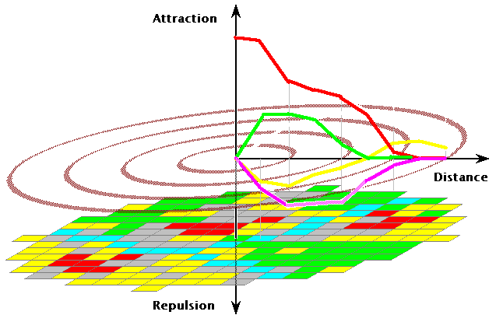

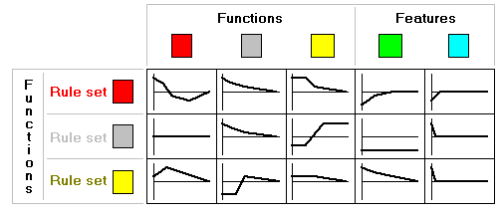

Fig. 19 The neighbourhood and example distance rules used in calculating the influence of neighbouring land use in the land use model. Each cell in the Influence Matrix would contain a relationship similar to the depicted graphs.

The influence matrix represents the most difficult part of the land-use model to develop and properly calibrate. Initial experiments with the prototype Waikato land-use change model indicated that land-use dynamics can be highly sensitive to the influence matrix relationships. Simple changes to only one or two relationships can profoundly affect the dynamics in terms of spatial patterns and rate of change. Therefore RIKS will most likely carry out land-use change calibration and develop the influence matrix, although options for increasing capability of users within New Zealand to perform calibrations will also be explored.

Links to Other Models
The Land Use Model has the most links to other models within the SDSS (Fig. 7). Land use will be affected by 1) water quality through influence on suitability or possibly resource management considerations, 2) zoning, 3) demography driving demand for more residential land, 4) WRDEEM setting land-use demands for different economic activities, and 5) dairying influencing land use change directly through the influence matrix or changing need for land. Land use in turn feeds back to WRDEEM based on changing economic land-use activities, water quality through the impacts of different land uses, and to biodiversity through changes to the total amount of natural versus non-natural land cover. The land-use model also generates a number of spatial indicators, including land use dynamics itself.

Preliminary Evaluation of the SDSS to Inform Policy & Planning
This section provides a preliminary analysis on how well the proposed SDSS does or does not appear to address the three key sources of information used to guide its development: 1) community outcomes and associated indicators from the Choosing Futures Waikato community consultation process; 2) key drivers identified in the qualitative scenarios under development in Objective 2; and 3) community outcomes from other regions within New Zealand. Evaluation of #1 is the most direct, straightforward, and objective, given the emphasis placed on SDSS ability to inform MARCO indicators at the SDSS workshop. Evaluation of #2 and #3 is mostly subjective at this stage.

Key Community Outcomes and related Core MARCO Indicators
As discussed earlier, the ability to inform, either directly or indirectly key community outcomes and in particular the core set of 75 MARCO indicators received strong consideration when developing the draft SDSS design. This section provides the full list of 75 core MARCO indicators arranged by community outcome theme and shows which of those indicators are informed directly or indirectly by the proposed SDSS.
Overall the proposed SDSS provides the most information for the sustainable economy and sustainable environment themes, followed by the quality of life theme, the culture and identify theme, and participation and equity theme (Table 13). This result is not necessarily surprising given the composition of the Objective 2 team and the nature of the indicators themselves. By design, the Objective 2 team consists of researchers with strong backgrounds in environmental sciences, ecology, economics, and demography.

Table 13 Number of core MARCO indicators directly or indirectly informed by the potential SDSS
Community Outcome Theme | # of Indicators | # Directly Informed | # Indirectly Informed | Gap
Sustainable Environment | 22 | 16 | 5 | 1
Quality of Life | 23 | 3 | 6 | 14
Sustainable Economy | 17 | 9 | 4 | 4
Culture and Identity | 10 | - | 3 | 7
Participation and Equity | 4 | - | - | 4

The indicators aligned with the well-represented sustainable environment and sustainable economy themes tend to be more objective and lend themselves more readily to quantitative analysis (Tables 14-18). The indicators in the participation and equity and culture and identify themes tend more towards social processes and perceptions that are inherently more difficult to model and measure. Quality of life indicators represent a mixture of quantitative and qualitative measurements.

The bias, such as it is, of the SDSS to the quantitative and biophysical/economic represents both a strength and a weakness. It is a strength because the SDSS and the models/components that it contains require explicit understanding, values, statements of assumptions, etc. Models do not tolerate uncertainty very well. For the same reason, this is also a weakness because much of the world is neither black nor white, nor do we necessarily easily interpret such hard facts when deliberating and making everyday choices. Our attitudes and behaviour often reflect more abstract thought processes that synthesise a range of information in more “fuzzy manners”. While much research exists to model such processes or more complex systems, the SDSS as currently conceived only tackles a certain aspect of the problem.

Key Drivers from the Qualitative Scenarios
Table 19 provides an initial assessment of the ability of the SDSS to address key issues identified in the qualitative scenarios for the Waikato region. Overall, the SDSS appears to provide a good coverage of the key issues identified in those scenarios. Economic and demographic issues appear the most well represented through NZCEE's WRDEEM and UoW PSC’s PROJECTIONS models, respectively. Other components of the SDSS address fewer issues, mostly at regional scales. Housing affordability and governance appear the least well addressed. These issues will be examined more closely as specifications for the SDSS are finalised.

Community Outcomes from Other Regions
Assessing the ability of the SDSS to address key drivers or issues for the four regions besides the Waikato is the most problematic and subjective and will only be briefly discussed at this stage. As discussed earlier, the original intent was to design a basic SDSS that included aspects of land use and land-use change, economics, and demography supplemented by number of issues perhaps of more relevance to the Waikato than anywhere else. The SDSS, as currently designed, does address those core issues and furthermore the additional components (climate change, water resources, biodiversity) appear relevant to the outcomes of the four other regions. The Dairying Model clearly has less relevance to Auckland and to some extent to Bay of Plenty, but otherwise the SDSS appears sufficiently basic and robust enough to be adapted to those other New Zealand regions without the need for major design modifications. Various model relationships and parameters would definitely require re-estimation or recalibration if transferred to another region.
Considering each of the other four regions individually, the SDSS seems to offer the best fit with Manawatu-Wanganui and Canterbury, given the inclusion of the water resources models. Bay of Plenty would likely benefit from the inclusion of more detailed horticultural models in addition to the Dairying model. Auckland would clearly require a fully-fledged transportation model and would not need the Dairying model.
Table 14 MARCO Sustainable Environment Indicators directly or indirectly informed by the proposed SDSS

Sustainable Environment
 |  |  | Global |  | NZ | Regional |  |  |  | District |  |  | Local
Outcome |  | Potential indicators/measures | Climate | Economy | Economy | Economy | Environment | Labour Force | Water Quality |  | Demography | Zoning | Biodiversity | Dairying | Land Use
Air, land, water quality and biodiversity | #1 | River water quality for ecological health | I |  |  | I | I |  | D |  |  |  | I | I | I
Air, land, water quality and biodiversity | #2 | River water quality for recreation | I |  |  | I | I |  | D |  |  |  | I | I | I
Air, land, water quality and biodiversity | #3 | Lakes water quality for ecological health | I |  |  | I | I |  | D |  |  |  | I | I | I
Air, land, water quality and biodiversity | #4 | Lakes water quality for contact recreation | I |  |  | I | I |  | D |  |  |  | I | I | I
Air, land, water quality and biodiversity | #5 | Land use | D |  |  |  | D |  | I |  |  | D | D | D | D
Air, land, water quality and biodiversity | #6 | Air quality (particulate matter, PM10) | I |  |  | I | I |  |  |  |  |  |  |  | I
Air, land, water quality and biodiversity | #7 | Groundwater availability and use |  |  |  |  | I
Air, land, water quality and biodiversity | #8 | Surface water availability and use | I |  |  |  |  |  | I
Air, land, water quality and biodiversity | #9 | Protection of natural heritage and landscapes |  |  |  |  |  |  |  |  |  |  | D |  | D
Air, land, water quality and biodiversity | #10 | Extent of native vegetation (forest, wetland, coastal) | I |  |  |  | I |  | I |  |  |  | D |  | D
Air, land, water quality and biodiversity | #11 | Protected native vegetation areas |  |  |  |  |  |  |  |  |  |  | D |  | D
Environmental attitudes and behaviours | #12 | People’s environmental attitudes | D? |  |  |  | I |  | I |  |  |  | I
Environmental attitudes and behaviours | #13 | People’s personal environmental actions | I |  |  |  | D |  | I |  |  |  | I |  | I
Coastal environment | #14 | Coastal water quality recreation | I |  |  |  |  |  | D
Coastal environment | #15 | Public access to coast (or Coastline ownership) |  |  |  |  |  |  |  |  |  |  | I |  | I
Rural environment | #16 | Rural subdivision |  |  |  |  |  |  |  |  |  |  |  |  | D
Rural environment | #17 | Stock density |  |  |  |  |  |  | D |  |  |  |  | D
Energy | #18 | Total energy consumption |  |  |  | I | D |  |  |  |  |  |  | D
Energy | #19 | Greenhouse gas emissions | I |  |  | I | D |  | I
Energy | #20 | Energy efficiency |  |  |  | I | D
Solid waste | #21 | Waste to landfills |  |  |  | I | D
Solid waste | #22 | Proportion of recycling |  |  |  | I | D

Table 15 MARCO Quality of Life Indicators directly or indirectly informed by the proposed SDSS

Quality of Life
 |  |  | Global |  | NZ | Regional |  |  |  | District |  |  | Local
Outcome |  | Potential indicators/measures | Climate | Economy | Economy | Economy | Environment | Labour Force | Water Quality |  | Demography | Zoning | Biodiversity | Dairying | Land Use
Health | #23 | Life expectancy at birth |  |  |  |  |  |  |  |  | D
Health | #24 | Social deprivation index
Health | #25 | Avoidable mortality and hospitalisation rates |  |  |  |  |  |  | I
Health | #26 | Overall quality of life |  |  |  |  |  |  | I
Health | #27 | Barriers to accessing General Practitioners
Education | #28 | School leavers with no formal qualification |  |  |  |  |  |  |  |  | I
Education | #29 | Educational attainment of the adult population |  |  |  | I |  | I |  |  | I
Education | #30 | Participation in early childhood education |  |  |  |  |  |  |  |  | I
Education | #31 | Adult and community education |  |  |  | I |  |  |  |  | I
Education | #32 | Work opportunities matching skills |  |  |  | D |  | D
Housing | #33 | Rent to income ratio
Housing | #34 | Housing affordability
Housing | #35 | Home ownership rate
Housing | #36 | Household crowding |  |  |  |  |  |  |  |  | I
Housing | #37 | Proximity to work, study, recreation |  |  |  |  |  |  |  |  |  |  |  |  | D
Community safety | #38 | Criminal victimization rates (or Reported criminal offences and resolution rates
Community safety | #39 | Perceptions of safety
Community safety | #40 | Road traffic injury rates
Community participation | #41 | Unpaid work
Sport and leisure | #42 | Participation in sport and active leisure
Family and community cohesion | #43 | Participation in social networks and groups
Family and community cohesion | #44 | Contact between young people and their parents
Youth and older people | #45 | Youth and older people engagement in decision-making

Table 16 MARCO Sustainable Economy Indicators directly or indirectly informed by the proposed SDSS

Sustainable Economy
 |  |  | Global |  | NZ | Regional |  |  |  | District |  |  | Local
Outcome |  | Potential indicators/measures | Climate | Economy | Economy | Economy | Environment | Labour Force | Water Quality |  | Demography | Zoning | Biodiversity | Dairying | Land Use
Sustainable development | #46 | Genuine Progress Indicator |  |  |  | D | D
Economic prosperity | #47 | Regional Gross Domestic Product (GDP) | I |  |  | D |  |  | I
Economic prosperity | #48 | Unemployment rate |  |  |  | D |  | D |  |  | I
Economic prosperity | #49 | Median weekly income |  |  |  | I |  | I |  |  | I
Economic prosperity | #50 | Number of businesses and employees by industry |  |  |  | D |  | D
Economic prosperity | #51 | Building consents |  |  |  | I | I
Transport, infrastructure and services | #52 | Drinking water quality | I |  |  |  |  |  | D
Transport, infrastructure and services | #53 | Road traffic crashes and casualties
Regional planning | #54 | Resident’s confidence in council’s decision making
Regional planning | #55 | Resident satisfaction with council's approach to planning and providing services
Land-based industries | #56 | Regional GDP contributed by primary industries |  |  |  | D |  |  |  |  |  |  |  | D
Tourism | #57a | Nights in commercial accommodation |  |  |  | I
Tourism | #57b | Regions visited by international visitors and nights spent |  |  |  | I
Tourism | #58 | Income from tourism (international and domestic) |  |  |  | D
Tourism | #59 | Employment in the tourism industry |  |  |  | I |  | D
Research and innovation | #60 | Total research funding |  |  |  | D
Research and innovation | #61 | Enrolments at tertiary education institutes (by type of study) |  |  |  | I |  | I |  |  | I

Table 17 MARCO Culture and Identify Indicators directly or indirectly informed by the proposed SDSS

Culture and Identity
 |  |  | Global |  | NZ | Regional |  |  |  | District |  |  | Local
Outcome |  | Potential indicators/measures | Climate | Economy | Economy | Economy | Environment | Labour Force | Water Quality |  | Demography | Zoning | Biodiversity | Dairying | Land Use
Regional identity and pride | #62 | Resident's rating of their sense of pride in the way their city/town looks and feels
Regional identity and pride | #63 | Number of Maori speakers (in Maori and in total population)
Regional identity and pride | #64 | Proportion of population that speak the ‘first language’ of their ethnic group
Historic buildings and places | #65 | Number of buildings and places listed on Historic Places Trust register |  |  |  |  |  |  |  |  |  |  |  |  | I
Historic buildings and places | #66 | Number and proportion of heritage buildings demolished or removed from heritage records |  |  |  |  |  |  |  |  |  |  |  |  | I
Historic buildings and places | #67 | Design of new developments |  |  |  |  |  |  |  |  |  |  |  |  | I
Culture and recreation | #68 | Resident’s satisfaction with cultural facilities provided
Culture and recreation | #69 | Participation in cultural and arts activities
Culture and recreation | #70 | Proportion of council's spending on cultural activities and events
Creativity | #71 | People employed in cultural sector

Table 18 MARCO Participation and Equity Indicators directly or indirectly informed by the proposed SDSS

Participation and Equity
 |  |  | Global |  | NZ | Regional |  |  |  | District |  |  | Local
Outcome |  | Potential indicators/measures | Climate | Economy | Economy | Economy | Environment | Labour Force | Water Quality |  | Demography | Zoning | Biodiversity | Dairying | Land Use
Civic participation | #72 | Percentage of voter turnout at local and general elections
Civic participation | #73 | Degree of representation by tangata whenua and minority groups on governance and decision-making bodies
Civic participation | #74 | Residents satisfaction with Council's provision of opportunities for community involvement in decision making | I |  |  |  |  |  | I
Cultural wellbeing | #75 | Percentage of residents perceiving that cultural diversity makes their region/ city/town a better place to live

Table 19 Subjective assessment of SDSS ability to inform key issues identified in the Waikato qualitative scenarios
Issue | How potentially informed by the SDSS?
World
- Climate Change: increased instability, extremes, and spatial variation | Climate Change Scenarios
- Population: migration trends, potential climate refugees | External Drivers, PROJECTIONS emigration estimates
- Market changes: number, size, access, preferences, locations | External Drivers
- Globalisation: R&D investment, | External Drivers
New Zealand
- Population - older, increasing proportion of Maori, Pasifika, and Asians; decreasing proportion of Pakeha/Europeans | PROJECTIONS Model – addresses overall population aging but ethnicity not currently considered (although theoretically possible)
- Lifestyles: changing expectations, influence of technology | WRDEEM estimates of technological change; estimates of final demands and exports
- Economy: agricultural intensification, new metrics, bio-economy | WRDEEM, Land Use Model – land-use intensification trends through suitability measures
- Energy: availability, affordability, mix of renewable/non-renewable | WRDEEM – energy demand by economic sectors
- Housing: affordability, increasingly urban culture | Not clearly addressed
Waikato Region
- Land use: intensification; change trends; management and influence on intensity of flooding, erosion, slips | Land Use Model, WRDEEM, Dairying Model; Hydrology Water Quality, Biodiversity
- Auckland: urbanisation pressures | Land Use Model via suitability/accessibility; PROJECTIONS via demand for housing
- Economy: agricultural intensification | Dairying, WRDEEM
- Governance: continued devolution versus greater central authority | Not clearly addressed although zoning or suitability reflecting resource management rules possible

Next Steps
This report provides the set of draft specifications for the Choosing Regional Futures SDSS. The specifications include the broad system design or ‘wiring diagram’, more detailed information for the proposed set of model components that comprise the SDSS, and an initial assessment of the linkages among the different model components.
The next step in the process of designing the SDSS specifications requires interacting with end-users, particularly staff at Environment Waikato, to review draft SDSS specifications and determine how well they fit with their current and emerging needs for policy development and resource management under the LGA and RMA. Overall, the scope of the SDSS appears to be appropriate, given the resources available in the Choosing Regional Futures project. Inclusion of new or additional model components or features would likely require scaling back or removing some of the model components currently included in the overall system design.
Under Objective 1 an alignment workshop will be held where researchers and end-users will come together to examine the draft SDSS specifications, identify gaps and suggest possible changes, and decide amongst various options that have been arisen during development. In other words, the alignment workshop offers a critical opportunity for researchers and end-users to decide “what’s in” and “what’s out” and therefore represents a critical step in SDSS development.
To assist the critical review of the draft SDSS specifications in preparation for the alignment workshop, a number of questions and options are outlined below. They have been organised into 2 groups: questions related to the overall SDSS design and questions related to options of individual model components. These are not meant as an exhaustive list and other issues or options will undoubtedly arise as both researchers and end-users further explore the SDSS.

Overall SDSS Design
These questions reflect considerations about the overall SDSS design and how well it might meet various end-user needs or, more to the point, how well end-users understand how well the SDSS addresses their needs.
- Does the overall SDSS design and specifications appear appropriate?
- Are their key components missing that should be included to address critical issues? In other words, are boxes missing that should be there and what do they contain?
  - Transportation?
  - Energy?
  - Others?
- Do the initial links identified among model components make sense? Which links should be removed? Which links should be added?
- Spatial Hierarchy
  - Should the SDSS include a farm scale between local and district scale? Technically feasible but could be cost prohibitive.
  - Should the SDSS track some issues by catchment boundaries rather than districts or the entire region?
- Could the SDSS better inform aspects of Participation & Equity and Culture & Identity community outcome themes?

Specific Options for Recommended Model Components
These questions relate to different options available for the different proposed model components. For consistency, the questions or options have been organised into the four scales proposed in the draft SDSS specifications:
- Global Scale
  - What external drivers could be or should be included in the SDSS?
  - Should external drivers be preset based on estimates from published sources or should users have the ability to change them? Some combination of the two?
- Regional Scale
  - WRDEEM – how many economic sectors to include? 48 is typical but greater or fewer sectors are also feasible.
- District Scale
  - Demographics
    - Currently only age and sex considered. Should other aspects be considered such as family or household structure? Ethnicity?
    - Include Statistics NZ district demographic projections as a reference?
- Local Scale
  - Biodiversity Model
    - Would the inclusion of additional information such as pest management operations and related outcomes be desirable?
  - Land Use Model
    - Spatial resolution: 200 x 200-m v. 400 x 400-m v. other?
    - Finalise Land Use Classes
    - Suitability Layers - keep simple and static or invest in making them more detailed and/or dynamic?
  - Spatial Indicators – develop a list of spatial indicators that the SDSS generates directly or that could be generated by combining other data?

Acknowledgements
The Foundation for Research, Science, and Technology funds the Choosing Regional Futures project under Contract ENVW0601 to Environment Waikato. Environment Waikato also provides co-funding for D. Phyn and B. Huser. Landcare Research co-funded early SDSS development as part of the Sustainable Futures Waikato Capability Fund project. The authors would like to thank Bob Frame and Richard Gordon for their helpful reviews, Anne Austin for editorial oversight, and Brenda Hall for word processing and document formatting.
References
Alexander RB, Elliott S, Shankar U, McBride GB 2002. Estimating the sources of nutrients in the Waikato River Basin, New Zealand. Water Resources Research 38(12): 1268–80.
Antunes CH, Dias LC 2007. Managing uncertainty in decision support models foreword to the special issue, Decision Support Systems 43(4): 1451-53.
Bandaragoda C, Tarboton DG, Woods RA 2004. Application of TOPNET in the Distributed Model Intercomparison Project. Journal of Hydrology 298(1–4): 178–201.
Cameron M, Cochrane W, Poot J 2007. End-user informed demographic projections for Hamilton up to 2041. PSC Research Report. Hamilton, Population Studies Centre, University of Waikato.
Chi G, Voss PR 2005. A modest proposal for improving small-area population forecasts. Paper presented at the 52nd Annual North American Meetings of the Regional Science Association International, Las Vegas.
Choosing Futures Waikato 2006. MARCO Benchmark Indicator Data Report 2006. 192 p. Available at: http://www.choosingfutures.co.nz/files/Marco%20Benchmark%20 Indicator % 20Report %20-%20December%202006.pdf
de Kort IAT, Booij MJ 2007. Decision making under uncertainty in a decision support system for the Red River. Environmental Modelling & Software 22: 128-36.
Department of Prime Minister and Cabinet 2003. Sustainable Development for New Zealand: Programme of Action. Wellington, New Zealand, Department of Prime Minister and Cabinet. 30 p.
Dharmalingam A, Pool I (eds) 2005. Population projections: stochastic simulation techniques and applications, Special issue NZ Population Review 31(1). Wellington, Population Association of New Zealand.
Elliott AH, Alexander RB, Schwarz GE, Shankar U, Sukias JPS, McBride GB 2005. Estimation of nutrient sources and transport for New Zealand using the hybrid mechanistic-statistical model SPARROW. Journal of Hydrology (NZ) 44(1): 1–27.
Engelen G 2003. Development of a decision support system for the integrated assessment of policies related to desertification and land degradation in the Mediterranean. In: Giupponi, C., Shechter, M. (Eds.), Climate change in the Mediterranean: socio-economic perspectives of impacts, vulnerability and adaptation. Cheltenham UK, Edward Elgar.
Funtowicz S, Ravetz J. 1991. A new scientific methodology for global environmental issues. In Costanza R ed. Ecological economics: the science and management of sustainability. New York, Columbia University Press. Pp 137–52.
Harris R 2004. Development versus protection, an introduction to RMA and associated laws. In: Harris R ed. Handbook of environmental law. Wellington, Forest and Bird Protection Society of New Zealand. Pp. 56–76.
Leathwick J, Wilson G, Rutledge D, Wardle P, Morgan F, Johnston K, McLeod M, Kirkpatrick R 2003. Land environments of New Zealand: Nga Taiao o Aotearoa. Auckland, David Bateman. 184 p.
Leathwick, J, Morgan F, Wilson G, Rutledge D, McLeod M, Johnston K 2003. Land environments of New Zealand: a technical guide. Auckland, David Bateman. 237 p.
Lee W, McGlone M, Wright E. 2005. Biodiversity inventory and monitoring: a review of national and international systems and a proposed framework for future biodiversity monitoring by the Department of Conservation. Landcare Research Contract Report 0405/122 prepared for the Department of Conservation. 213 p.
Ludwig D 2001. The era of management is over. Ecosystems 4: 758–764.
Maré D, Timmins J 2004. Internal migration and regional labour markets in New Zealand. Wellington, mimeo, Motu Economic and Public Policy Research.
Oxley T, Jeffrey P, Lemon M 2002, Policy relevant modelling: relationships between water, land use and farmer decision processes. Integrated Assessment 3 (1): 30–49.
Parliamentary Commissioner for the Environment 2002. Creating our future: sustainable development for New Zealand. Wellington, New Zealand, Office of the Parliamentary Commissioner for the Environment. 182 p.
Poot J 1986. A system approach to modelling the inter-urban exchange of workers in New Zealand. Scottish Journal of Political Economy 33(3): 249–274.
Rutledge D, Price R, Heke H, Ausseil A 2004. National analysis of biodiversity protection status: methods and summary results. Landcare Research Contract Report LC0405/038 prepared for the Ministry for the Environment. 30 p.
Simpson S, Middleton L, Diamond I, Lunn D 1998. Small-area population estimates: a review of methods used in Britain in the 1990s. International Journal of Population Geography, 3(3): 265–280.
Sprague RH, Carlson ED 1982. Building effective decision support systems. Englewood Cliffs, Prentice-Hall. 329 p.
Tayman J, Swanson DA 1996. On the utility of population forecasts. Demography 33(1): 523–528.
Van Delden H 2000. A generic approach for the design of Decision Support Systems for river basin management. Civil Engineering & Management. Enschede, The Netherlands, University of Twente. P.106.
Walker S, Price R, Briggs C, Rutledge D 2004. New Zealand’s remaining indigenous cover: recent changes and biodiversity protection needs. Landcare Research Contract Report LC0405/038 prepared for the Department of Conservation. 76 p.
Walker S, Price R, Briggs C, Rutledge D 2005. Remaining indigenous covers on pastoral leases: priorities for biodiversity protection. Landcare Research Contract Report LC0405/163 prepared for Land Information New Zealand. 62 p.
Walker S, Price P, Rutledge D, Stephens T, Lee W 2006. Recent loss of indigenous cover in New Zealand. New Zealand Journal of Ecology 30(2): 169–177.
Woods RA, Henderson RD 2003. Surface water components of New Zealand’s National Water Accounts, 1995-2001. NIWA Client Report No. CHC2003-074. 50 p. Available on-line via http://www.stats.govt.nz/analytical-reports/natural-resource-accounts/water-natural-resource-accounts.htm

WRDEEM cannot therefore be expected to capture ‘short term’ fluctuations in economic activity such as those arising from cyclical commodity price fluctuations. Other models, such a Computable General Equilibrium (CGE) models, are better suited for such purposes.
Commodity use is expressed as a linear Leontief production function.
The latest being Thiagarajah Ramilan, Frank Scrimgeour and Dan Marsh. Institutional analysis for nitrogen pollution abatement in a Waikato river sub-catchment in New Zealand AARES 51st Annual Conference 2007, Queenstown, February 2007.
Report available online at http://www.riks.nl/projects/MedAction.

